SCALING CLIMATE ACTION THROUGH CLIMATE TECHNOLOGY AND INNOVATION BY SMEs
Climate Screening and Opportunity Toolkit & Business Carbon Footprint Toolkit Training Manual

Table of Contents
Basic definitions/glossary of key terms 2
Introduction 3
Target Audience 4
Module 1 | Climate risk screening – what are the climate risks for business? 4
Module 2 | Climate action – what are the opportunities for businesses and entrepreneurs? 7
Module 3 | Climate change mitigation – how are greenhouse gas emissions relevant to business? 9
Module 4 | Greenhouse Gas Accounting – what methods are available for businesses to apply? 11
Module 5 | Accessing climate finance – opportunities and pitfalls for small business? 15
Complete the flowchart checklist to find out what type of funding is best suited to your business 21
Module 6 | Climate Change Tools Application – why, when, and how to use the tools? 22
Toolkit 1: Climate Risk Screening and Opportunity Toolkit 25
Purpose of this toolkit 25
Toolkit 2: Business Carbon Footprint Toolkit 45
Purpose of this toolkit 45
References 51

Basic definitions/glossary of key terms
Climate change: Climate change is the change in average conditions over a long period of time. Whilst weather describes the current conditions in a specific place (e.g. rain, wind, snow etc.), climate describes the expected weather conditions in a region at a certain time of year (NASA, 2020). Therefore, climate change describes the change in the average weather conditions in a region over a long period of time. However, changes in the Earth’s climate since the 20th century have been driven primarily by human activities, especially the burning of fossil fuels (NASA, 2020). This has drastically increased the level of greenhouse gas released into the atmosphere. Since greenhouse gas increases the heat trapped in the earth’s atmosphere, this has resulted in temperature rise, commonly termed global warming.
Sustainable Development Goals (SDGs): The Sustainable Development Goals comprise of 17 global goals which provide a “blueprint” for achieving a more sustainable future for all. The SDGs were officially adopted in 2015 by the United Nations Generally Assembly, with the goal of being achieve by 2030 (United Nations, n.d). Link to more information: https://sustainabledevelopment.un.org/
Climate change impacts: Physical changes that occur as a result future climate. As an example, a decrease in average rainfall into the future will lead to drier conditions. This will directly impact the way in which agriculture is conducted in affected areas or affect the availability of water resources, for example (Tonmoy and Rissik, 2019).
Climate change risks: What a given climate change impact will pose to your business and its operations. For example, if your business is involved in producing agricultural output, increased dry conditions caused by less rainfall may increase the risk of crop losses (decreased output) or increase the cost of irrigation (increased production costs) leading to less profit (Tonmoy and Rissik, 2019).
For more information on the risks that climate change could have on your business, seethe “Business Risks, Opportunities and Leadership” report by the Centre for Climate and Energy Solutions (C2ES, 2019):
https://www.c2es.org/site/assets/uploads/2019/04/business-risks-opportunities-and-leadership.pdf).
Climate change adaptation: Steps that businesses, governments, communities, and individuals can take to deal with the risks that climate change impacts pose. For example, for the same agricultural business at risk of drought, this business can plant heat-resistant crops that can survive with low moisture content (Tonmoy and Rissick, 2019).
Relationship between climate change impacts, risks, and adaptation: Climate change is very likely to increase both the frequency and intensity of extreme weather events such as flooding, heatwaves, droughts, bushfires, cyclones and extreme rainfall, to name a few. These changes will have different impacts for the various sectors within which small businesses operate (e.g. energy, agriculture, construction and trade, tourism, food and beverage, retail and hospitality etc.). For businesses at the individual scale, these impacts will be contextualised differently as climate impacts pose business specific risks. These risks are based on factors such as:
- how exposed is a business to extreme climate events,
- what the likely consequences are for businesses is a potential risk is realised,
- how capable and equipped the business is to deal with risks (for some businesses, climate change will pose new risks, but for others, climate change may also provide new opportunities too).
Climate resilience: Climate resilience is the strengthening of the ability of both of systems (human and non-human) to be able to cope with ad respond to the changes in the earths climate. Climate resilience can be built through increasing adaptation and mitigation actions to both adapt to, and prevent the impacts of climate change.
Climate change mitigation: Steps that businesses, governments, communities and individuals can take to reduce or prevent the emission of greenhouse gases using new technologies, renewable energy, as well as rehabilitating ecosystems, improving energy efficiency of old technology, and changing consumer and societal behaviour and practices (IPCC, 2014). For example, a business involved in agriculture production may choose to use renewable energy sources, such as solar power to power irrigation pumps thus, reducing the consumption of energy and consequently, fossil fuel production.
Climate finance: Funding that seeks to reduce carbon emissions, and to enhance carbon sinks, while also aiming to reduce vulnerability, through maintaining and increasing the resilience of human and ecological systems to negative climate change impacts (UNFCCC, 2014).

GHG-specific terminology
Baseline: A calculation of GHG emissions under a Business as Usual (BAU) scenario (i.e. not changing anything in the business).
Base year: a specific year against which a business's GHG emissions are tracked over time
Base year emissions: GHG emissions in the base year
Carbon footprint: The total amount of carbon emissions (GHG emissions) released into the atmosphere as a result of activities from a business, organisation, community, household or individual.
CO2 equivalent (CO2-e): The global measurement unit of global warming potential (GWP), this includes each of the six greenhouse gases, expressed as the GWP (one unit of carbon dioxide)
For more information on GWP, see: https://www.epa.gov/ghgemissions/understanding-global-warming-potentials
Emissions: The release of GHG into the earth's atmosphere
Emission factor: This is a factor that allows GHG emissions to be estimated from a unit of activity data (such as litres of fuel consumed, kWh of electricity used etc.)
Climate change mitigation: Steps that businesses, governments, communities and individuals can take to reduce of prevent the emission of greenhouse gases using new technologies, renewable energy, as well as rehabilitating ecosystems, improving energy efficiency of old technology, and changing consumer and societal behaviour and practices (IPCC, 2014). For example, a business involved in agriculture production may choose to use renewable energy sources, such as solar power to power irrigation pumps thus, reducing the consumption of energy and consequently, fossil fuel production.
Greenhouse Gases (GHG): GHGs consist of six gases as listed in the Kyoto Protocol; carbon dioxide (CO2); methane (CH4); nitrous oxide (N2O); hydrofluorocarbons (HFCs); perfluorocarbons (PFCs); and sulphur hexafluoride (SF6).
For more information on the Kyoto Protocol, see: https://unfccc.int/kyoto_protocol

Introduction
Climate change will have drastic effects on country’s economies and force businesses to implement plans and strategies to reduce these impacts. Businesses that respond to these risks proactively, will reap the rewards of longevity and competitiveness. Despite the risks that climate change poses to businesses (discussed in more detail below), SMEs are well-placed to overcome and adapt to these risks given their agility and flexibility. This allows SMEs to capture new business opportunities and develop innovative solutions to climate change challenges.
This Toolkit training manual aims to help businesses understand how climate change risks affect businesses in general and the potential opportunities for business growth that exist in the climate change space. Module 1-5 provides information intended to equip users with this information and consequently, the knowledge and skills to use the tools that have been developed. Module 6 then provides a step by step guide in using each of the tools. This knowledge and these tools will help to position your business competitively in current and future markets and ensure greater access to sustainable finance and business opportunities.
At the end of this training manual you should:
- Have a greater understanding of climate change, climate change risks on your business, the opportunities for action that emerge from this risk, and various implementation options
- Be able to integrate climate action into your business/business ideas, and implement a level of risk management and growth​

Target Audience
These tools are targeted at SMEs in the private sector at various stages of the business continuum (see Figure 1).
For entrepreneurs at the beginning of the business development phase, these tools will aid in thinking through potential business ideas in terms of climate change risks and costs, and in identifying sustainable business opportunities that align with green financing objectives. ​
For businesses further along the business continuum, these tools will still prove useful in considering the impact of climate change to the business and the associated costs of taking action to overcome or adapt to such impacts. It will also help businesses to identify future opportunities that will help to reduce the impacts of climate change or assist in coping with these impacts. ​
For the AfDB, these tools will assist in vetting SME green finance applications and aligning these with AfDB climate change objectives







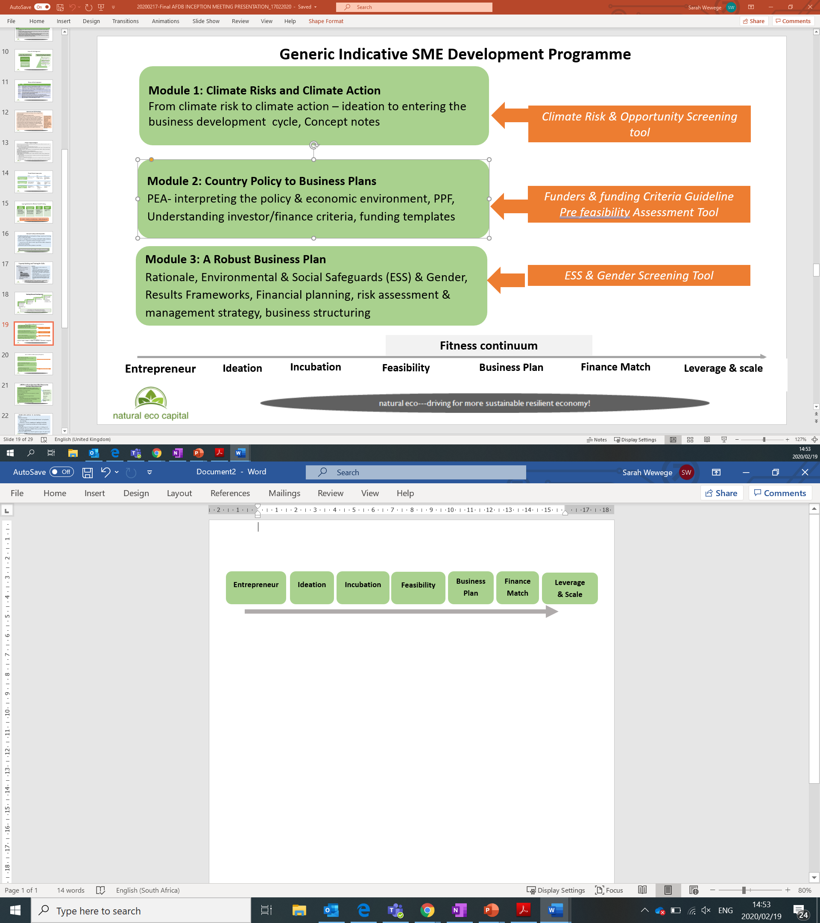
Figure 1. Business fitness continuum

Module 1 | Climate risk screening – what are the climate risks for business?

Climate change
Climate change is the change in average conditions over a long period of time. Whilst weather describes the current conditions in a specific place (e.g. rain, wind, snow etc.), climate describes the expected weather conditions in a region at a certain time of year (NASA, 2020). Therefore, climate change describes the change in the average weather conditions in a region over a long period of time. However, changes in the Earth’s climate since the 20th century have been driven primarily by human activities, especially the burning of fossil fuels (NASA, 2020). This has drastically increased the level of greenhouse gas released into the atmosphere. Since greenhouse gas increases the heat trapped in the earth’s atmosphere, this has resulted in temperature rise, commonly termed global warming.

Climate change impacts
The impacts of climate change will not be limited to geographical impacts, such as flooding, drought, and deforestation, but will have consequences for nearly every industry that exists, from finance to health, to education and agriculture. This is because climate impacts such as drought and flooding are crosscutting, with knock-on effects that will impact us all. According to the United Nations Intergovernmental Panel on Climate Change (IPCC), the leading international body on climate change, global GDP is projected to drop by 15% from 2010 levels should temperatures increase by 2.5 degrees Celsius (IPCC, 2018). Thus, global warming will have implications for business, employment levels and economies. For SMEs, climate change will directly and indirectly affect their businesses.
A few broad impacts of climate change on SMEs are outlined in Table 1 below.
Table 1. Broad impacts of climate change on SMEs
Impacts of climate change | Potential impacts on SMEs
  Temperature increase | This may make it difficult for employees to work outdoors; energy costs for the business could increase as businesses spend more on cooling equipment.
  Sea-level rise and extreme events such as flooding | Flooding can damage business assets (equipment and buildings), infrastructure (access to water and energy supply), disrupt supply chains and logistics, increase the cost of insurance, and increase costs for businesses (to pay for weatherproof storage facilities and buildings).
  Water scarcity due to drought | This could lead to increased resource competition and increase the price paid for this resource.
  Loss of biodiversity | This could lead to a change in natural resources available for product input materials (e.g. wood, minerals, food crops etc.). This could also affect tourism-related activities reliant on certain natural assets such as forests and coasts.
  Increase incidence of disease due to pollution | This can increase the cost of healthcare for individuals and pollution increases the health-risk of employees.

Overall, climate change impacts are likely to have an impact on business productivity, increase the cost of regulations and insurance, and lead to the damage or loss of businesses.
Productivity: Climate change will increase the spread of vector-borne diseases (e.g. malaria), decreasing the health of workers which will lead to absenteeism, resulting in less hours worked and decreased productivity. In addition to higher healthcare costs, increased migration and pollution will impact on supplier’s ability to deliver.
Cost of regulation and insurance: as the impacts of climate change continue to be felt (e.g. flooding, drought etc.), the cost of actions to safeguard against and adapt to these risks are likely to be borne by small businesses. Furthermore, insurance premiums will increase as climate impacts pose a greater risk to infrastructure damage, further increasing the cost of doing business.
Damage to/loss of business opportunities: climate change disasters and extreme weather events may lead to the shutdown of business facilities or tourist hubs, such as coastlines, preventing businesses from operating temporarily or even permanently.

Thus, it is critical to understand how different climate impacts may affect your business. More specifically, businesses should consider six broad climate risks to their business, which can be divided into two categories- value-chain risks and external stakeholder risks as outlined in more detail below (Engel et al., 2015).
Value-chain risks
- Physical risks can inflict damage on infrastructure and other business assets, such as factories, equipment and supply-chain operations. This is caused by the increased frequency and intensity of extreme weather events, such as floods, droughts, wildfires, storms or hurricanes for example. Physical risks are difficult to control, however, businesses can take steps to prepare for these climate events.
- Price risks refer to the increased price uncertainty of raw materials and commodities. For example, drought can lead to an increase in the price of water; climate-related regulation can result in increased energy costs. In the renewable energy and high-tech industries, increased demand for rare earths, needed in the production of computer hard drives, wind turbines, electric vehicles and solar photovoltaic systems, will lead to increased competition and therefore, likely price increases for these inputs.
- Product risks refer to products that can become unpopular or even unsellable over time. For example, alternative cooling technologies could displace air-conditioning systems; snorkeling or diving companies that rely on marine diversity and healthy coral reefs may close due to a loss of biodiversity/changing sea-patterns. Increased regulation and production costs could increase the price of coal above lower-carbon alternatives, affecting mining equipment manufacturers and related industries.

External-stakeholder risks
- Reputational risk can be direct, originating from a company-specific action or policy, or it can be indirect, and come from changing public perception of the overall industry. In the context of climate change, reputational risk can be understood in terms of the probability of a loss in profitability due to a business’s activities or position on certain issues that the public deems harmful. For example, a business that produces a lot of pollution tends to be viewed negatively by the public compared to a business that makes an effort to implement pollution-reducing activities into business operations. Public perception and consumer tastes play an increasingly important role in inter-connected world. Furthermore, investors need to ensure that their investments are protected and thus, business reputation plays an important role in securing finance.
- Regulation risk refers to government action that is prompted due to climate change. This varies and can include the introduction of rules that add costs to certain business activities (such as generation of non-renewable energy), inhibit certain business activities, provide subsidies in support of the growth of certain industries (e.g. the renewable energy sector) or withdrawal of subsidies. In many industries, government plays a key role in determining the rules of the game. With climate change and increasing pressure being placed on governments to adapt and mitigate against these impacts, there has been a push towards regulation that encourages and rewards businesses that promote climate change objectives (e.g. clean energy, pollution reduction, sustainable agriculture etc.) whilst penalizing those that don’t.

All of these possible risks need to be considered in developing a business idea or strengthening an existing business. Possible climate change impacts need to be considered through these key risks. This will help businesses to screen for key climate risks and the corresponding impacts. Some key questions to ask when considering these risks to your existing business or future business include:
- What are the possible impacts for my business in the short-term?
- What are the possible impacts for my business in the medium- to long-term?
- What actions can I take to minimize or prevent this risk from occurring?

Module 2 | Climate action – what are the opportunities for businesses and entrepreneurs?

Opportunity for SMEs
The global economy is changing and there is an increasing demand for environmental and sustainable goods and services. In order for businesses to be competitive, it is critical that they strategize and adopt an environmentally friendly and sustainable business model that will enable their participation in local and global markets, ensuring future competitiveness, profitability (and access to climate finance streams) and sustainable growth. Africa’s growing population translates into a growing market size. SMEs and the private sector are well placed to capitalise and benefit from this changing climate. Their smaller size and agility allow for flexibility, preventing path dependency and encouraging innovation.
Understanding how climate change impacts could affect your business and identifying opportunities to adapt to and mitigate against these impacts proactively, will help your business to:
Save costs: understanding how current and future climate risks will impact your businesses operational performance will enable you to make more informed investment decisions (Tonmoy and Rissick, 2019). This will help to lower costs in the long term as well as potentially decrease future insurance and lending costs.
Ensure business continuity: by addressing your business’s exposure to climate risks, this will provide your business with the best possible chance of continuing operations to meet demand and minimise potential disruption (Tonmoy and Rissick, 2019).
Competitive advantage: through identifying business opportunities that promote sustainability, finding ways to reduce business costs, and effectively managing climate risks, this will give your business upper hand over competitors.
Maintain a positive reputation: consumers and investors are increasingly putting pressure on businesses to adopt sustainable business practices that are environmentally friendly (Tonmoy and Rissick, 2019). Taking a proactive approach in addressing the impacts of climate change on your business will increase investor confidence and safeguard your business’s reputation.

Identifying business opportunities
The impact of climate change presents opportunities for innovation of new products and services that can help to reduce GHG emissions (see module 3) and adapt to the impacts of climate change. As a starting point, it is important to properly understand the climate-related risks that your business faces. Unlocking this knowledge allows for more effective planning and the enhancement of a business risk management plan. This will not only help to reduce long-term unexpected costs, but will also add value to the business reputation, making it a more attractive investment avenue for potential financiers. In addition to implementing strategies and actions to protect your business against climate risks, the process of identifying climate risks and impacts on businesses may present new business opportunities to explore. For example, drought is a climate impact that poses a significant risk to businesses across Africa, especially businesses in the agriculture sector where drought will threaten food security. In response to this risk, a business opportunity may be to develop a water-efficient irrigation product that farmers can use to limit their water use and allow for business continuity during periods of water scarcity.
As climate risks are considered, potential solutions to these risks can be further developed into new businesses. While all sectors provide opportunities for innovation given that climate change is crosscutting, there are some key sectors that should receive particular attention given that many climate investors and climate funds look to invest in these areas. These include energy, agriculture and industry. Some key questions to ask for each of these sectors includes:
Energy
- Is there an opportunity for my business to provide affordable and renewable energy to individuals and households?
- Can my business help to improve the energy efficiency of other businesses?
Agriculture
- Is there an opportunity for my business to provide sustainable farming methods/tools to farmers?
- Can my business help to protect businesses in the agriculture sector against climate change risks (infrastructure, livestock, supply chains etc.)?
Industry
- Can my business help to minimise waste in industrial processes?
- Can my business provide or create energy/water-efficient technologies for industry?
General
- Is there an opportunity to develop climate-friendly products or services?
- Can my busines help to reduce carbon emissions in upstream supply-chains and/or logistics?
- Can my business help other businesses to implement climate-risk management solutions that will protect them against climate impacts?

The case study below (Box 1), highlights how two entrepreneurs came up with an innovative product which was motivated by an increasing shortage of water in South Africa. Furthermore, access to adequate sanitation remains a challenge in South Africa (and globally), and consequently, this business solution sought to tackle this issue (sustainable development goal 6) whilst limiting the use of clean water (Mudombi, 2019).
Box 1. Case study: Retrofitting water saving in conventional waterborne sanitation systems
Loo Afrique was started by Rori Mpete and a colleague who, whilst visiting one of their grandmothers home, saw that the water basin was not working and thought to wash their hands in the cistern, given that the water that goes into this is clean (Mudombi, 2019). This sparked the idea to re-position the cistern lid upside down to function as a basin and cistern, allowing for hands to be washed and the wastewater to be used for flushing. Thus, this saves water and encourages the use of grey water usage (Mudombi, 2019).
Their innovative solution targets the water and sanitation sector through improving water efficiency and access to sanitation. This solution also targets SDG 6 (Ensure availability and sustainable management of water and sanitation for all), has a measurable impact on communities through job creation, are easily scalable and help to educate and create awareness amongst communities on water efficiency. While Loo Afrique is still in the process of strengthening its business for scaling-up, it provides a good example of a business model that fulfils the criteria of climate finance and thus, is well positioned in the green business space.

For more case studies to explore, the UK Climate Impacts Programme has an archive of case studies to consult by sector. You can access these here: https://www.ukcip.org.uk/case-studies/
Note that case studies will emerge from the six pilot countries as this project evolves.

Module 3 | Climate change mitigation – how are greenhouse gas emissions relevant to business?
Some key definitions:
Carbon footprint: a carbon footprint is the most accurate estimate of the total amount of carbon emissions (GHG emissions) released into the atmosphere as a result of activities from a business, organisation, community, household or individual (directly and indirectly) (Thompson, 2018).
Greenhous gases (GHG): These are the gases (CO_{2,} CH_{4,} N₂O, HFCs and SF₄₎ that warm the planet by trapping heat into the atmosphere. GHG is measured to calculate your carbon footprint (Thompson, 2018).
Electricity generation and use, transportation, industry and agriculture present a few of the largest sources that contribute to GHG emissions. These are sources over which businesses have direct control and consequently, strategies can be implemented to promote cleaner energy sources, more efficient use of energy and production methods, as well as behaviour change to decrease the emission of GHGs.
Carbon uptake/sequestration: The act of long-term removal of carbon dioxide from the atmosphere to slow down or reverse pollution and mitigate against global warming. While CO₂ is captured from the atmosphere through biological, physical and chemical processes, this process can be accelerated through changes in land use and agricultural practices (e.g. converting livestock grazing and crop land into land for fast growing non-crop plants).

Since climate change and specifically, global warming, poses a significant threat to our planet overall, trying to limit the rate at which climate change accelerates is critical in order to slow down the impacts that climate change will pose. There is mounting evidence that reducing GHG emissions can help to slow down the impacts of climate change. The Paris Agreement, a global environmental accord that was adopted in 2018 and currently signed by 197 countries, aims to address climate change and its impacts (UNFCCC, 2020). This agreement is underpinned by the commitment from each country signatory to reduce GHG emissions and thus, limit the rise in temperature to 2 degrees Celsius above pre-industrial levels with the goal of achieving 1,5 degrees (UNFCCC, 2020).
In order to achieve this, countries developed nationally determined contributions (NDCs) which includes their emission reduction targets and implementation efforts. Box 2 explains how GHG emissions are related to business activity and highlights the relevance of accounting for and reporting on these emissions.

Box 2. What are GHG emissions and why should my business care?
The Greenhouse Gas Protocol categorises GHG emissions in three scopes. These scopes present how gases are emitted and how much control businesses have in each case.
- Scope 1: Direct GHG emissions from sources that are owned or controlled by the business (Ranganathan et al., 2004). This includes things like company vehicles, fuel combustion (e.g. boilers, furnaces or turbines), process emissions (cement, aluminium and waste processing) and fugitive emissions (air conditioning and refrigeration leaks, methane leaks from pipelines etc.).
- Scope 2: Indirect emissions associated with consumption of purchased or acquired electricity, steam, heating, or cooling (Ranganathan et al., 2004).
- Scope 3: All other indirect emissions not included in scope 2. Scope 3 emissions are a consequence of the business’s activities but are released from sources outside its organisational boundary (Ranganathan et al., 2004). This includes employee travel or emissions released by an organisation’s supplier for example.
The importance for businesses to measure and track their carbon footprint:
- Carbon foot printing will help to benchmark your business’s current consumption in order to plan for reduction over time (Thompson, 2018). The cost of electricity is rising, regulations are becoming more stringent and carbon taxes are increasingly becoming mainstreamed- these are all things that will impact your business. Therefore, understanding the sources in your business that consume the most energy/fuel and emit the largest quantity of emissions, can help your business to implement strategies to reduce these emissions and ultimately, the cost that these impose.
- Carbon foot printing can help your business identify problems (unnecessary expenses) as well as opportunities and innovative solutions in the market as common business constraints emerge.
- Understanding your business’s carbon footprint helps with GHG reporting which can help to attract investors and climate finance as robust evidence is presented. Furthermore, increasing pressure from consumers necessitates transparency and a sense of social responsibility for businesses.

If businesses are able to identify and measure the GHG emissions that they produce, they can develop an inventory of these emissions which will help these businesses to understand the indirect and direct impacts of business operations on GHG emissions. Understanding this then allows for businesses to identify where changes can be made to reduce GHG emissions stemming from business operations or, to identify business opportunities and actions that contribute to carbon uptake.
Accounting and reporting for business GHG emissions is important for a number of reasons:
- It is great for business reputation:
Globally, consumers are placing more pressure on businesses to adhere to environmental standards. Businesses that are environmentally friendly will gain a competitive advantage over businesses that are not (Zokaei, 2013).
- GHG reporting increases the efficiency of your business:
Reporting highlights your businesses energy use and management of resources making it easier to identify opportunities for greater efficiency, areas of cost reduction and waste elimination (Chamberlain, n.d)
- Investors are attracted to GHG reporting:
Investors like to invest in businesses that have the potential for long-term investment and sustainability. Reporting not only provides ways to make your business more sustainable but it also creates accountability and transparency. This helps to position your business as an attractive long-term investment for potential funders (Chamberlain, n.d).

Module 4 | Greenhouse Gas Accounting – what methods are available for businesses to apply?
As outlined in Module 3, it is beneficial for businesses to be able to calculate and report on their GHG emissions. To do this, businesses need to understand some basic GHG Accounting principles in order to be able to identify business GHG emissions sources and conduct simple calculations needed for reporting.

GHG inventory and organisational boundaries
A GHG inventory consists of a list of all your businesses GHG emissions sources and quantities (TCR, 2015). Organisational boundaries are the total operations, facilities and sources that comprise your business. Thus, being able to identify your organisational boundary and what you do or don’t have control of, is critical to begin the GHG accounting process. There are two main approaches to defining your organisational boundary. These are:
The equity approach where the business accounts for the GHG emissions according to its share of equity in the business operation.
The control approach where the business accounts for 100% of the emissions it has control over. Control can be defined according to operational or financial control.
- Operational control is all the things that your business has complete authority over. For example, your business can decide what vehicles to purchase and when to use them. Furthermore, your business may operate out of a rented office space, while not owning the office space, your business still has direct control over how much electricity to consume (TCR, 2015).
- Your business also has financial control over an operation and can decide where to direct finances and how to spend money (TCR, 2015). The operational and financial control approach can be easily adopted by businesses to report on GHG emissions. Once these boundaries have been established, businesses can start to calculate GHG emissions using the following steps:
Process adapted from Bhatia and Ranganathan, 2004

Identify GHG emissions sources
As a starting point, it is important that businesses categorise their GHG emissions according to direct and indirect emissions which are broken down into three scopes.
Scope 1, direct emissions are those activities that the business has direct control over. Unless a business operates in the manufacturing sector where emissions are generated from cement manufacturing or aluminum smelting, scope 1 emissions will come from operating a business-owned vehicle, combustion device, air-conditioning or refrigeration equipment (Bhatia and Ranganathan, 2004).
Scope 2, indirect emissions are emissions that arise for the consumption of purchased electricity, heat, or steam. Most businesses will generate indirect emissions from these activities.
Scope 3, indirect emissions are all other indirect emissions that are generated in a business’s upstream or downstream operation, as well as from outsourced manufacturing activities, franchises, or leases (Bhatia and Ranganathan, 2004). Should businesses wish to report on scope 3 emissions, this will allow the business to identify relevant GHG emissions along their value chain and highlight potential opportunities for reducing GHG emissions. For example, they could switch to a supplier that uses renewable electricity as opposed to a current supplier that uses coal-based electricity to produce key inputs needed in the business.
The most common activities in your business which may release GHG, could include (DEFRA, 2009):
- Electricity or gas use
- Waste disposal or recycling
- Business travel
- Vehicles that your business owns or controls
- Your employee business travel
- Staff commuting
It is important that your business accounts for as many emission sources as it can, that fall within your businesses operational and financial control. Writing these down and categorizing them accordingly, will help in beginning the GHG calculation process.
For more detail on what category an emission source falls into, see Appendix D of The Greenhouse Gas Protocol: A Corporate Accounting and Reporting Standard: https://bit.ly/3gHntlj

Select a GHG emissions calculation approach
Whilst GHG emissions can be measured directly by monitoring the concentration and flow rate, or calculated according to mass or other mathematical calculations (stoichiometry), the most common approach is through the application of prescribed and documented emission factors (Bhatia and Ranganathan, 2004).
What is an emissions factor?
An emission factor is a metric that shows how much of a GHG is emitted into the atmosphere based on a measurable quantity of an activity (TCR, 2015). For example, it calculates the metric tons of CO2 emitted per kWh of electricity used. Given that the six greenhouse gases have different heat-trapping abilities and different lifespans in the atmosphere, when calculating a business’s total GHG emissions or ‘carbon footprint’, it makes sense to report this in a common metric. Therefore, emissions factors for the different GHGs are used with the relevant activity data (e.g. the usage of electricity) in order to convert them into global warming potential (GWP) values (The Climate Registry, 2019). GWP represents all of the different emission sources from GHGs relative to carbon dioxide. Thus, all emissions are reported in metric tonnes of CO₂ equivalent to provide a single metric that encompasses all of the GHGs (TCR, 2019).

While facility or source-specific emission factors are preferable to use in calculating GHG emissions since they are more accurate, generic or general emission factors can be used where this data is not available. Default emission factors have been developed and published and can help your business to complete its GHG inventory. These can be found on a variety of platforms which include the IPCC emission factor database (https://www.ipcc-nggip.iges.or.jp/EFDB/main.php) or the Carbon Trust website (https://prod-drupal-files.storage.googleapis.com/documents/resource/public/Conversion%20factors%20guide%20-%202016.pdf), or your country may have specific default emission factors of their own.
For industrial companies, there are other approaches and methodologies that can be used that are targeted towards these specific industries (e.g. the International Aluminum Institute, International Iron and Steel Institute) that have sector specific guidelines. These can be found on the GHG Protocol website (www.ghgprotocol.org).

Collect activity data
Once you have identified the emission sources your business will report on, you need to collect the relevant activity data for each source (TCR, 2015). This activity data may include distance travelled, fuel consumption and type of equipment. Keep records of this activity data as it will help your business complete its GHG inventory.
For SMEs, scope 1 GHG emissions will be calculated using receipts or bills from purchased commercial fuels, such as petrol, heating oil and natural gas. Scope 2 GHG emissions will be calculated primarily through metered electricity use and published emission factors. SMEs will calculate scope 3 emissions data using activity data such as passenger kilometers, fuel use and published emission factors. Essentially, your business should already have most of the information you need to gather this data. Sources of information to collect common data for emission- releasing activities are shown in the table 2 below:
Table 2. Common data for emission-releasing activities
Emission-releasing activity | Source of information
Electricity use | Total kilowatt hours used from electricity bills
Natural gas use | Total kilowatt hours used from gas bills
Water supply | Total water supplied in cubic metres (m3) from water bill
Water treatment | Total water treated in cubic metres (m3) from water bill
Fuel use in company owned vehicles | Litres of fuel purchased from invoices and receipts  (more accurate); or  Vehicle mileage from vehicle log books/odometers  (less accurate)
Employee passenger travel | Employee receipts for details of travel, and  Use distance calculation websites to obtain flight, rail and road distances
Waste disposal/recycling | Tonnes of waste-to-landfill and recycled from waste collection provider
Table taken from DEFRA, 2009

Apply calculation tools and convert the data
In order to calculate your GHG emissions associate with each activity identified, you will need to convert your activity data using emission factors.
There are two ways of doing this. The first is by using an online calculator of which there are many available online. For example, the GHG Protocol Initiative website (www.ghgprotocol.org) has a number of calculation tools that can be applied to general businesses since they are cross-cutting, as well as more specific sectors tools, such as the energy sector.
The second way is by using emission factors to complete the calculation below (DEFRA, 2009):
Activity data x emission factor= GHG emissions
Since you have collected the activity data, you will need to use the appropriate corresponding emissions factor to convert your activity data into GHG emissions.

Report on GHG emissions
It is important to report GHG emissions over time and account for changes. Key categories that are common to GHG reporting include (Bhatia and Ranganathan, 2004):
- A short description of the emission sources
- A list that clearly explains the inclusion or exclusion of sources (for example, your business may have chosen to exclude certain scope 3 emissions data since it was unreliable and thus, not useful)
- Information that can be compared over time- it is important to report over as et time period consistently
- The reporting period that has been covered
- State whether any progress has been made towards reaching a specific business target
- State any uncertainties in activity, fuel use or emissions data reported. Explain the likely cause of this and how data can be improved going forward.
- Describe any changes or events that will/have had an impact on reported data. This may include business acquisitions, closures, technology upgrades, changes of calculation methodologies or reporting boundaries etc.
Overall, some key guiding principles for GHG accounting are listed below:
- Relevance: Make sure that your GHG inventory reflects your business’ GHG emissions.
- Completeness: Ensure that your business accounts for and reports on all GHG emission sources and activities that fall within your businesses defined inventory boundary.
- Consistency: It is important to use consistent methodologies to enable meaningful comparisons of GHG If data sources change or your businesses inventory boundary changes, this must be recorded.
- Transparency: Be clear in your reporting, disclose any relevant assumptions and clearly state what accounting methods and data were used.
- Accuracy: Try and be as accurate as possible with the quantification of your businesses GHG emissions. This enables investors to use the reported information and make decisions with reasonable confidence based off of the integrity of the data.

For further reading on this topic, feel free to consult the following useful resources:
- Guide on how to measure and report your greenhouse gas emission (https://bit.ly/2ZR3R7x)
- Greenhouse Gas Reporting for Small Businesses (https://bit.ly/3eb2963
- Greenhouse Gas Protocol: A Corporate Accounting and Reporting Standard (https://bit.ly/2DpuRDC

Module 5 | Accessing climate finance – opportunities and pitfalls for small business?
“Climate finance” refers to money – both from public and private sources – which is used to help reduce emissions and increase resilience against the negative impacts of climate change.”- Timperley, 2018

What is climate finance
To respond to the impacts of climate change, there is a need for large-scale investment into mitigation and adaptation actions to help combat the negative impacts of climate change. Mitigation measures help to reduce emissions, notably in sectors that emit large quantities of GHG. Of equal importance, is the need to invest in adpatation measures which help countries adapt to the negative effects of climate change and help reduce these impacts. Therefore, finance directed at these measures and which aim to adress climate change, is termed climate finance.
Climate finance can be categorised into three types:
- Mitigation finance is directed at projects/businesses that limit the onset of climate change. For example, low-carbon initiatives that encourage energy efficicency, renewable energy projects and reforestation projects (to help trap carbon) are the types of initiatives financed (Wyns, 2018).
- Adaptation finance is directed at projects/businesses that provide solutions that help individuals/community/society adapt to the impacts of climate change (Wyns, 208). For example, a business that builds sea-walls to adapt to sea-level rise or the development of water-efficient irrigation systems to help farmers farm sustainably and protect them during drought are the types of initiatives financed.
- REDD+ is finance that is invested to protect forests and encourages reforestation projects. These projects/businesses are sometimes called carbon trading schemes since they help to absorb carbon dioxide from the atmosphere (Wyns, 2018). REDD+ stands for educing emissions from deforestation and forest degradation, conservation of existing forest carbon stocks, sustainable forest management and enhancement of forest carbon stocks (FAO, 2020).
In 2018, mitigation activities accounted for approximately 93% of global climate finance (CPI, 2019). About 63% of mitigation finance was invested into renewable energy generation, about 26% was invested into low-carbon transport, and about 6% was invested into energy efficinecy (CPI., 2019). A reason for the dominance in mitigation activities is since the benefits and impacts of these activities are easier to quantify and thus, provides more concrete evidence for investors.
Therefore, for SMMEs that contribute, or want to contribute to climate adaptation actions, developing and communicating a strong climate rationale will be more difficult compared to those SMMEs contributing to climate mitigation. This is since measuring and quantifying the benefits and co-benefits (larger societal impacts) of adaptation actions are less concrete and more challenging to report on. A strong climate rationale is eseentially being able to present a strong evidence base by linking climate change impacts, your businesses actions, the estimated benefits of those actions, and the potential for scale-up. This is a critical starting point for SMEs in order to enhance the bankability of the business and increase opportunities for climate financing.
Some key questions to answer for your business as a strating point for buidling a strong climate rationale include (aka the evidence base that ensures the linkages between climate change impacts, the climate action your business takes, and the subsequent benefits are well communicated and underpinned by the best available climate information):
- Do I understand how certain climate risks will impact my business or business idea?
- Does my business take clear action to prevent these risks or mitigate against these risks?
- OR does my business make a positive contribution towards adaptation/mitigation measures?
- How does my business do this and what are the direct and indirect results or impact?
- Do I have evidence to back up my results/proposed effects of my business action?
- Can this be quantified and proven?
- How does my business idea/proposal fit into the broader domestic and inetrnational policies related to climate change and decision-making processes?
If you can answer these questions, you are on your way to developing a strong climate rationale for your business which is a critical starting point towards accessing climate finance.

Challenges in accessing climate finance
Across Africa, access to finance remains the biggest barrier for the growth and survival of SMEs. While climate finance is available, there is a lack of knowledge and awareness of these existing channels of access and the requirements needed to unlock these financing opportunities. Some of the key barriers that prevent SMEs in Africa from being able to access climate finance includes:
- Opportunities in climate change-related space are not well articulated or understood amongst SMEs and investors alike. Financing plays a key role in enabling and driving investments and innovation in the eco-inclusive space. Financing climate resilience, however, as well as the instruments for doing so, remain unclear. There is a lack of understanding of the investment opportunities arising from climate change adaptation among financial institutions and entrepreneurs alike. Such opportunities are therefore not mainstreamed into the strategies and priorities of financing organisations. Climate-vulnerable livelihoods, for example, such as small-holder farming or rural tourism, present new market opportunities for financial institutions. There is, however, a high level of uncertainty and risk which comes with financing climate adaptation and the mechanisms for mitigating for these are not well understood, particularly in the context of the most vulnerable communities. Enabling and financing investment opportunities in climate resilience requires a shift in the way traditional financial institutions and mechanisms are perceived.
- SMEs are often ill-equipped to meet financier requirements or fund metrics to secure funding and access markets. Adaptation initiatives contribute towards broader socioeconomic development objectives. However, in order to qualify for climate financing, they need to demonstrate that they contribute to climate change mitigation/adaptation and have the potential for transformational change, in addition to business feasibility etc. This can be difficult to communicate for SMEs that do not have a strong understanding of climate change. Furthermore, many SMEs do not fulfil key criteria like having a good credit record or collateral for the business. The lack of capacity to identify transformational projects that contribute to adaptation goals (amongst SMEs and financiers alike), as well as a lack of institutional, financial and technological capacity to adapt effectively by both financing organisations and beneficiaries, is a significant barrier to accessing climate finance.
- Lack of access to knowledge assets (accessing information through knowledge partners, such as universities and research centres, to inform and support SMEs adoption of environmental technologies) plus, the cost of doing research and development (R&D) is extremely high. Moreover, the lack of awareness and information about alternative forms of funding is one of the key reasons for SMEs not approaching formal financial organisations for funding. Other important barriers are the difficulty of the funding application process, which SMEs also find very time consuming and complex.
- Structural hurdles remain a significant barrier for SMEs to conduct business. Whilst structural hurdles differ from country to country in Africa, some common barriers include a lack of access to reliable and affordable internet, infrastrucutre needed to run a business (such as access to buildings and office space, reliable transport, water and electrciity), as well as the regulatory environment where enabling policies that support SMEs and the growth of businesses are not present.

Opportunities for accessing climate finance
Despite the challenges that exist for SMEs to access climate finance, there are opportunities that exist for climate financing and therefore, it is critical that SMEs are equipped with the knowledge of what is needed and what diffeernt investors look for, in order to position businesses favourably. Figure 2 below summarises the some key general features that strengthen the business case and enabling a higher chance of accessing financing. While climate finance may be targeted at businesses or projects that contribute to adpatation and mitigation measures, general criteria for accessing financing and for what investors look for, remains the same for general financing as well as climate financing.
Figure 2. Business leverage to raise/access funding: Decreasing strength of business case to access climate financing and financing in general
Business/SME is part of a larger business (has a parent company that provides support, financing, and know-how

Business/SME is already profitable

The business/SME has a strong business plan that points to profitability

The business/SME has a strong sustainability component/aligns with mandates/criteria of government, SDGs and climate financing funds

Source: (ClimaSouth, 2016)

Table 3 and 4 below, give a brief overview of the types of financiers that exist and the key criteria that these financiers look for in order to invest or grant finance to businesses. It is important to note that SMEs/businesses at different stages of the business fitness continuum will require/be able to access certain types of funding depending on their needs and various stages. Therefore, Table 3 highlights the key financing options available to early stage entrepreneurs whilst Table 4, highlights the financing opportunities available for SMEs/businesses further along the business fitness continuum. While this list is not comprehensive, it aims to provide information on the key climate financing avenues available for SMEs/businesses.

Table 3. Financing Options available to early stage entrepreneurs
Family and friends | Angel investors look for: businesses where they can make money, take calculated risks, invest for a fixed period of time, own shares in the company, can be paid back on their investment
Family and friends tend to lend money or assets such as vehicle, computer, printer etc. Generally, they require that you simply pay them back for the money borrowed with the interest that money would have earned. Family and friends can also provide surety for loan applications. This means that if you are unable to secure collateral money to repay the loan, your friend/family member (who provided the surety) is responsible for paying the amount owed with any interest due. | - A business idea  - Strong entrepreneurial characteristics (in an individual) and a good team  - Disruptive/innovative products  - A large or growing market  - Existing clients  - Profit potential  - Scalable business opportunity  - Clear exit for the investor
Crowdfunding | Government funding
Raising of finance from a larger network of individual investors who contribute smaller amounts of money (generally via the internet). | - Grants: generally, not repayable with governments providing 100% of financial need. These tend to be once off to assist new businesses  - Cost-sharing grants: these grants generally range from 35%-100% of the funding application and will require businesses to fund the remaining balance  - Incentives: unlike grants that are paid upfront, incentives are paid out after specific actions. Businesses can claim back a portion of their project cost if it addresses a certain incentive.  - Tax incentives: this provides businesses with the opportunity to deduct a certain amount of money that it would normally owe to tax. Government offers tax incentives to help encourage businesses to pursue specific activities for a period of time (e.g. employing people under the age of 35)  Equity funding: this is when the government funding agency buys a portion of the business in return for shares in your business.
Incubators and Enterprise Development (ED) programmes | Social enterprise funding/ impact investing
These programmes help to support the growth and acceleration of SMMEs and entrepreneurial companies through financial and non-financial support services (e.g. mentorship, low-cost workspaces, access to investors and funding opportunities, loans etc.). | Finance that is provided to businesses that generate environmental and social impacts in addition to financial return
Table 4. Financing options for SMEs further along the business continuum (e.g. have established feasibility, business plan, customer base etc.)
Banks (LOANS) look for: collateral, viability of business, affordability of the repayments, clear credit record for business and owners | Government looks for:
- A strong business case- facts and figures, financial statements, and reports  - Cash flow and profit forecast  - Exposure of businesses to risks  - Minimisation of risk (banks want to lend money if they know it can be secured through collateral)  - Businesses must be ‘finance ready’ (this means that the business has the necessary information available) | - Socio-economic driven goals (job creation, improved wealth distribution etc.)-gender, youth employment, job creation  - Sector-driven goals  - Innovation  - Competitive edge  - Legal compliance
Angel investors/venture capitalists look for: businesses where they can make money, take calculated risks, invest for a fixed period of time, own shares in the company, can be paid back on their investment | Debtor financiers  (this option will only work if your business generates a reasonable monthly turnover)
- Strong entrepreneurial characteristics (in an individual) and a good team  - Disruptive/innovative products  - A large or growing market  - Existing clients  - Profit potential  - Scalable business opportunity  - Clear exit for the investor | - Customer profiles (preferred customers are large, reputable and have an excellent credit record). Clients indicate whether a business is high or low risk  - A decent average monthly turnover (to make the investment worthwhile), as the cost of doing initial due diligence on clients is high  - Healthy debtors’ book  - Business must be viable (profitable and healthy with collateral) as this decreases risk in the case that customers don’t pay
Niche SMME financiers  (these are more flexible than banks) | Multilateral Development Banks (MDBs) look for:
- Strong entrepreneurial characteristics  - Collateral  - Viability of a business (financial statements and forecast)  - Affordability of repayments  - A clear credit record for the business and owners  - Various business documentation | - Good credit worthiness  - Measure of development effectiveness (jobs created, socio-economic-environmental co-benefits etc.)  - This financing is usually channelled through a financial intermediary (banks, credit unions, insurance companies etc.)
Green Funds look for:
- Impact potential
- Paradigm shift potential
- Sustainable development potential (economic, social, and environmental co-benefits, gender empowerment etc.)
- Country ownership

The climate financing checklist in Toolkit 1 (covered in Module 6) will help your business identify what criteria climate financiers tend to look for. It is important to note that for multilateral climate funds and large development banks, there is a strong focus placed on gender and promoting gender equality and fairness (Paul, 2019). For example, in the Green Climate Fund’s comprehensive gender-responsive approach, gender mainstreaming and the meaningful inclusion of women underpins its mandate, guiding principles and funding objectives. Research shows that there is enormous potential for the success of women-led businesses given that women in poorer areas especially, tend to be more reliable than men (see Box 3 below). Thus, it is critical that climate financing instruments, such as microfinance, are feasible for both women and men.
Box 3. Importance of climate finance access for women
In low-income societies, women are the most vulnerable and poorest members of society (CIF, 2018). However, women in these regions are also viewed to be more reliable borrowers of credit compared to men (CIF, 2018). In Africa, as of 2018, women comprise 64% of microfinance customers (Convergences, 2019). Research shows that climate actions favoured by women tend to have numerous developmental benefits and low risks, leading to increased climate resilience for communities (Petrie et al., 2012). Furthermore, women’s connections in the community allow for quick learning as to what does and doesn’t work, enabling the implementation of successful adaptation/mitigation ideas to be replicated elsewhere. Thus, women-led adaptation/mitigation businesses are prime candidates for investment and cost-effective scaling up (Petrie et al., 2012).

The flowchart below will help your business assess how ready it is to access climate finance or finance in general. It is important to note that this is not a comprehensive flowchart and is applicable to accessing general financing and climate financing. The purpose is to help guide your business in the right direction towards applying for funding.

Complete the flowchart checklist to find out what type of funding is best suited to your business
Phase 1: Early stage entrepreneur
Next steps: Approach family/friends, public sources of seed funding (crowdfunding) and/or community and faith-based organisations, foundations, incubators and enterprise development programmes, seed finance.
Q: Business/SME has seed funding?



Business plan has been completed

Next steps: Approach financiers not looking to make financial returns/not looking for shares. These include public sources (supported by Climate Funds etc.) and incubators and enterprise development programmes to make the business economically viable.
Q: Business/SME is economically feasible? (strong business case as identified in the Opportunity Assessment Checklist)
Phase 2: Business/SME development stage

Next steps: Approach sources of private finance such as debt from local banks, government funding, equity from venture capitalists, impact investors, crowdfunding etc.

Business has secured funding to implement business plan
Phase 3: Business/SME scale-up & growth

Businesses/SMEs search for additional rounds of funding to scale-up and growth their businesses.

Next steps: Approach financiers not looking to make financial returns/not looking for shares. These include public sources (supported by Climate Funds etc.), social enterprise funding/impact investing to make the business economically viable.
Q: Business/SME remains economically feasible?

Next steps: Approach sources of private finance such as debt from local banks, debtor financiers, niche SMME financiers, larger banks and international banks (e.g. MDBs), equity from more established venture capitalists, impact investors, crowdfunding etc.

Business/SME will continue to leverage development finance as growth and scale-up continues.

Module 6 | Climate Change Tools Application – why, when, and how to use the tools?
Many opportunities are unfolding for private sector companies to implement actions towards reducing risks to their business operations, as well as investing in adaptation action in vulnerable regions in a sustainable and profitable manner, including:
- New market opportunities and expansions, for example in water resource development in response to water security challenges from climate change;
- Development of climate friendly goods and services, such as waste management services and technologies;
- Potential cost savings, for example through energy efficiency solutions that reduce input costs for businesses while also reducing greenhouse gas emissions;
- Risk reduction measures, including physical operations, such as flood management in small and large scale mining operations at sever risk from increased and more intense flood events;
- Climate proofing the supply chain; and
- Enhanced corporate social responsibility.

Therefore, the purpose of these climate change toolkits is to assist your business to de-risk its operations, and to seize opportunities in the green economy, thus helping scale up climate action on the continent. These tools will aim to provide practical and technical solutions to:
- Identify risks and risk mitigation strategies for business operations (from both a climate adaptation and mitigation perspective), with a view to both de-risking the business and the financier from climate impacts;
- Identify business opportunities that arise from proactive participation in climate action;
- To strengthen business planning alignment with available funding, and;
- To enhance in-country capacities and enabling environments to attract investments from a wide variety of sources.

This section provides a step-by-step guide on using the two toolkits. The first toolkit (Toolkit 1) is called the Climate Risk Screening and Opportunity Assessment Toolkit. The second toolkit (Toolkit 2) is called the Business Carbon Footprint Toolkit. Both toolkits consist of various steps that will help your business to think through the risks and opportunities that exist in the climate change space. An overview of the Climate Screening and Climate Opportunity Toolkit and Business Carbon Footprint Toolkit, and their key functions are outlined in Table 5.

Table 5. Climate Risk Screening and Opportunity Toolkit and GHG Accounting Toolkit Overview
Toolkits | Objectives of the Toolkit
Toolkit 1: Climate Risk Screening and Opportunity Assessment Toolkit | - Enable businesses to identify and develop sustainable business ideas and initiatives that align with national climate change strategies and objectives, climate financing criteria and country sustainable development objectives, to increase their probability of receiving climate financing; ​  - Climate proof their businesses as appropriate in terms of climate risks for long-term sustainability and growth and; ​  - To integrate climate response strategies into business operations and to account for achievements made each year of the business lifecycle, thus enhancing the preparation of bankable businesses in the green space and increasing access to climate finance.
Toolkit 1 steps (a)-(g):

Toolkit 2: Business Carbon Footprint Toolkit | - Help businesses to estimate their businesses carbon footprint  - Help business to reflect on ways to reduce decrease their carbon footprint, thus contributing to climate change objectives and helping to save costs for the business  - Measure and report on their GHG emission reductions annually
Toolkit 2 steps (a)-(c):

Toolkit 1: Climate Risk Screening and Opportunity Toolkit

Purpose of this toolkit
The following tools will help guide businesses to screen their businesses for climate risk and identify risk reduction strategies, as well as to identify new business opportunities that arise from climate change response strategies, and that have potential for sustainable economic growth.
Specifically, the purpose of the Climate Risk Screening and Opportunity AssessmentToolkit is:
- Enable businesses to identify and develop sustainable business ideas and initiatives that align with national climate change strategies and objectives, climate financing criteria and country sustainable development objectives, to increase their probability of receiving climate financing;
- Climate proof their businesses as appropriate in terms of climate risks for long-term sustainability and growth and;
- To integrate climate response strategies into business operations and to account for achievements made each year of the business lifecycle, thus enhancing the preparation of bankable businesses in the green space and increasing access to climate finance.
This toolkit is comprised of seven consecutive steps (steps (a)- (g)), as outlined in Table 1 and shown again below, to help your business screen for climate risks and identify climate opportunities. The STOP/GO points are there to help your business see if it should continue, or if it should gather more information/rethink the business/business idea to begin with. For example, if after step (c) you discover that your business is not aligned with any funding criteria, it is probably better that you re-think certain aspects of your busines, or your business entirely, since it is highly unlikely that your business will be successful in receiving climate financing.

Step a) Risk and Vulnerability Screening Checklist
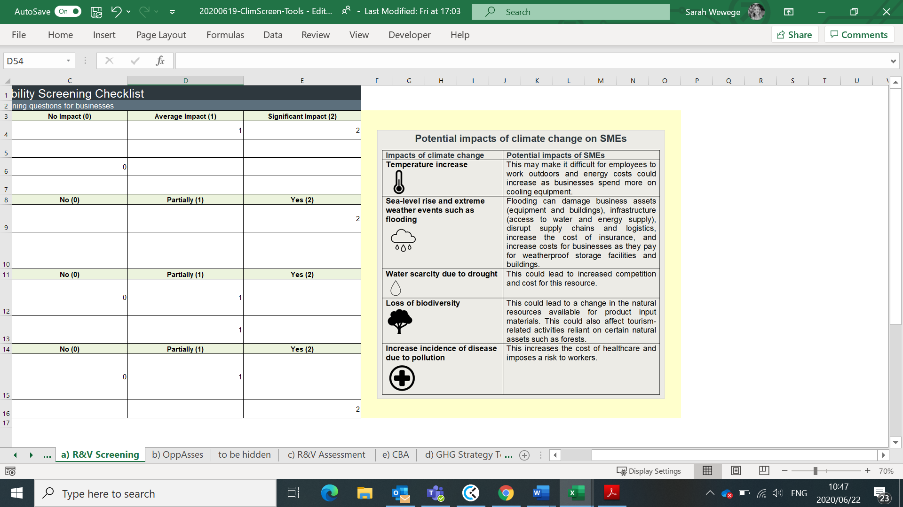
The first step is to compele the the risk and vulnerability screening checklist. The purpose of this checklist is to highlight some key impacts that climate change may have on your business that you may not have considered before. Box 4 below, in the tool, provides some key examples of these potential impacts. By answering some simple questions (as shown in Screen Image 1 below), you will be able to see the areas of your business that are most exposed to risk. This will help to highlight the areas of your business that need greater attention in terms of risk management and climate proofing.

Box 4. Potential impacts of climate change on your business (above)
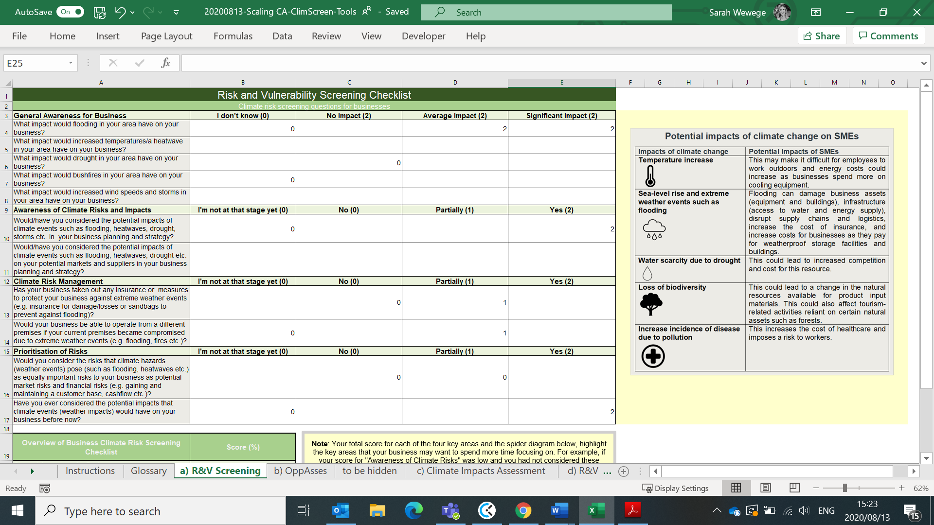
Screen Image 1. Risk and vulnerability screening checklist
For example, based on the checklist and scoring system above, the spider diagram below (Screen Image 2) reveals that the areas of “climate risk management” and “awareness from business”, need the most attention in order to protect the business against future climate risks.
Screen Image 2. Climate risk management priorities
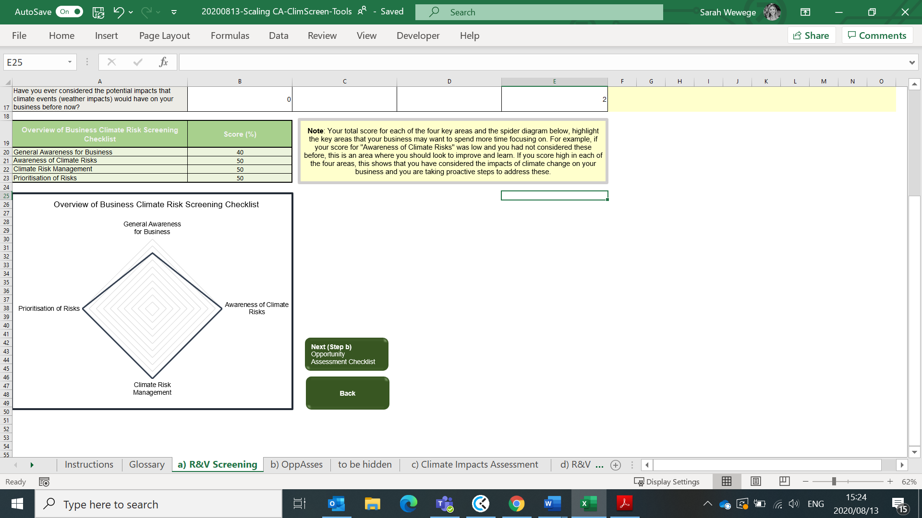

Step b) Opportunity Assessment Checklist

For entrepreneurs at the beginning of the business development phase, this assessment tool will help to highlight key investment criteria to build into their business idea.
For businesses further along the business continuum, this assessment tool will help businesses re-think and re-align their business strategy.



This opportunity assessment tool asks key questions aimed at assessing the alignment of your business and its vision to general climate finance objectives and criteria. Furthermore, it asks questions that will assess whether or not your business addresses some of the Sustainable Development Goals (SDGs) (see Box 5 below). This will be automatically generated based on your answers given. If you find that your business has weak alignment with the SDGs (or very few), or you answer “no” or “I don’t know” to the questions on feasibility, suitability, impact and sustainability, you should re-think your business plan or strategy. This is since climate finance institutions and green investors want to invest and give finance to businesses that align with the SDGs and NDCs, make economic sense, and will have a sustainable impact on society and the economy. Each question that is asked relates to some form of green/climate financing criteria. Therefore, careful consideration and incorporation of these factors should be mainstreamed into your business to maximise the potential for accessing finance and encouraging investment.
Box 5. The Sustainable Development Goals (SDGs) and Nationally Determined Contributions (NDCs)
Information on the Sustainable Development Goals (SDGs) and the Nationally Determined Contributions (NDCs)
The 2030 Agenda for Sustainable Development (with the SDGs at its core) and the Paris Agreement on climate change (which produced the Intended Nationally Determined Contributions- INDCs) were developed in parallel and adopted within a few months of each other in 2015.
At the heart of the Paris Agreement were the INDCs, where each country would draft its national efforts to take by 2020 in order to fulfil the objectives of the Paris Agreement and prevent global temperature rising above 2°C. Nationally Determined Contributions (NDCs) embody the efforts of each country to decrease their national emissions and adapt to climate change impacts (United Nations Climate Change, 2020). To date, 186 countries have submitted their first NDCs with 3 countries having submitted their second NDCs (NDCs are to be updated every five years and thus, countries are expected to update their NDCs in 2020).

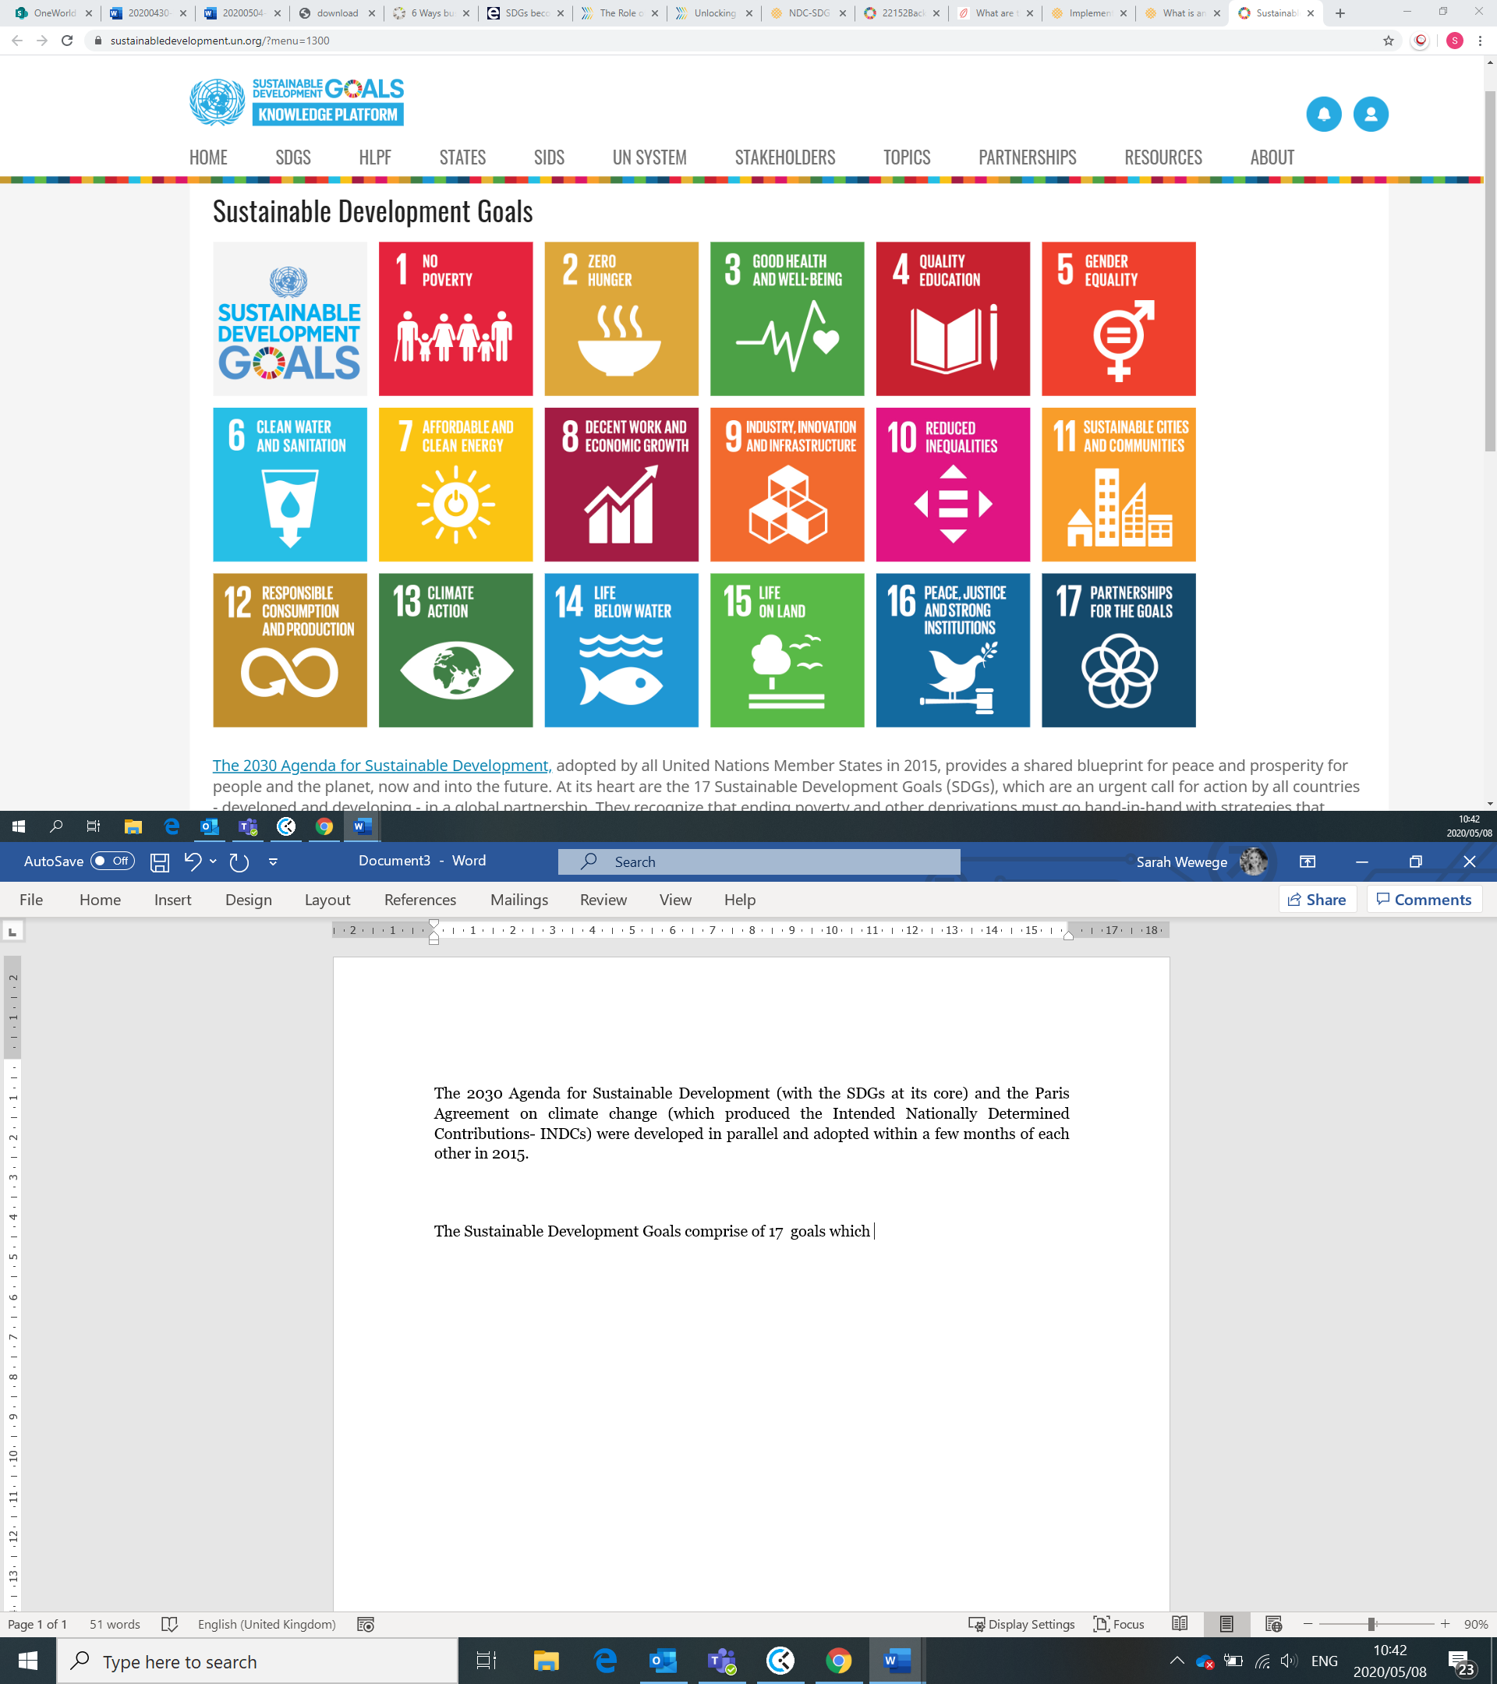
The Sustainable Development Goals comprise of 17 global goals which provide a “blueprint” for achieving a more sustainable future for all. The SDGs were officially adopted in 2015 by the United Nations Generally Assembly, with the goal of being achieve by 2030 (United Nations, n.d)
(Source: United Nations, n.d)
For more information on the SDGs and NDCs, and to better understand these investment criteria, please view the links below:
- For a better understanding of the SDGs and how to integrate these into your business, please visit the Sustainable Development Goals Knowledge Platform: https://sustainabledevelopment.un.org/ and GRESB Insights https://gresb.com/6-ways-business-align-sdgs-make-impact/
- For more information on your country’s NDCs, please visit the UNFCCC NDC Registry: https://www4.unfccc.int/sites/NDCStaging/Pages/All.aspx
- For more information on the type of climate change business opportunities, please see the African Financial Alliance on Climate Change brochure: https://www.afdb.org/fileadmin/uploads/afdb/Documents/Generic-Documents/AFAC_Brochure_2018.pdf

In excel, you will complete the first step of this toolkit by completing the Opportunity Assessment Checklist. As shown in the Screen Image 3 and 4 below, there you will outline your business idea, select the sector your business falls under and answer a number of questions related to SDG targets.
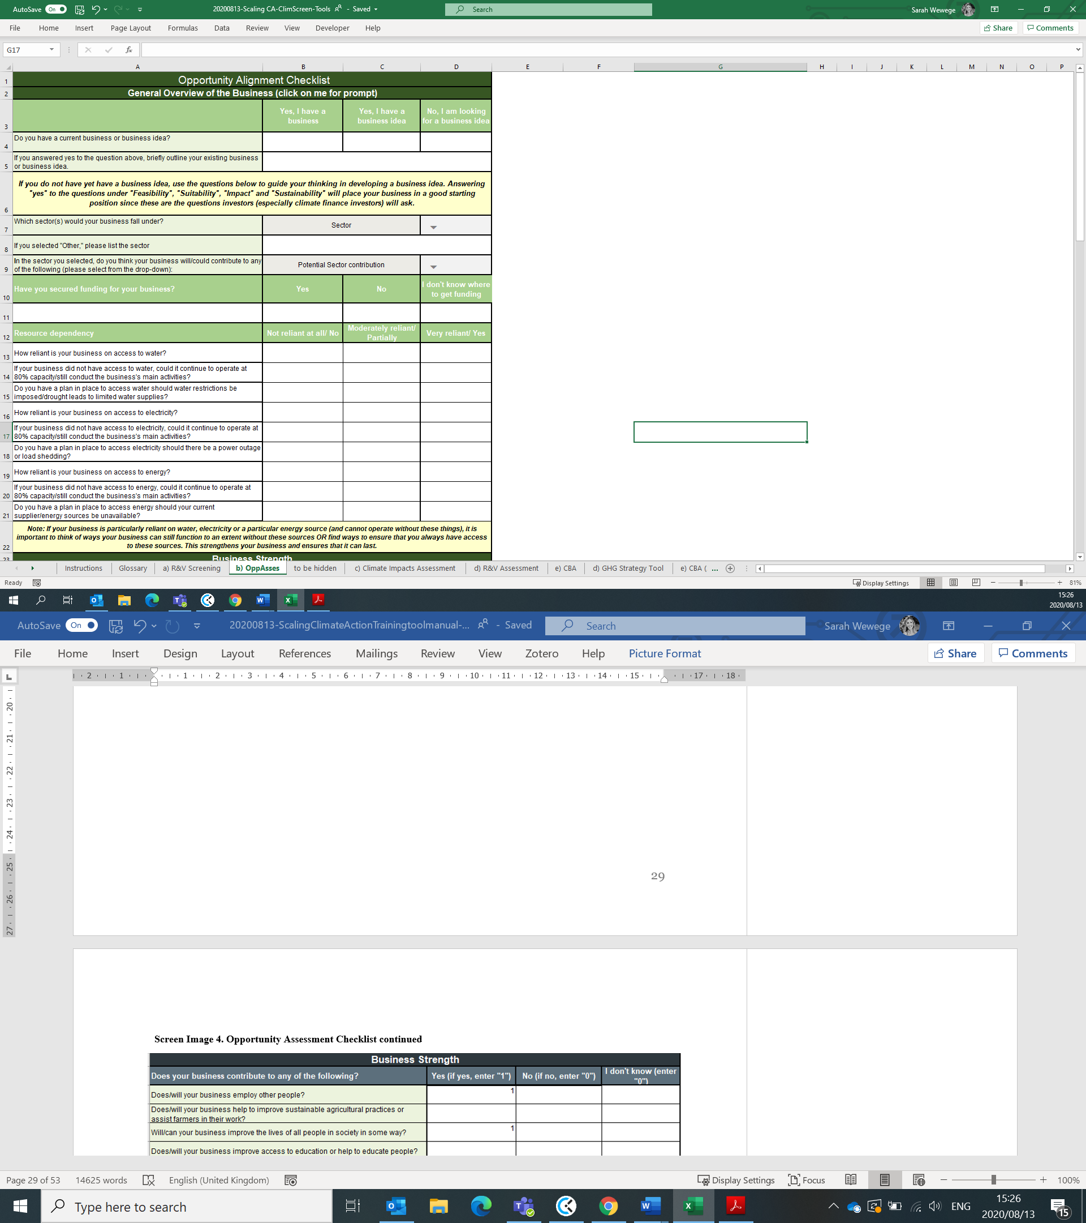
Screen Image 3. Opportunity Assessment Checklist

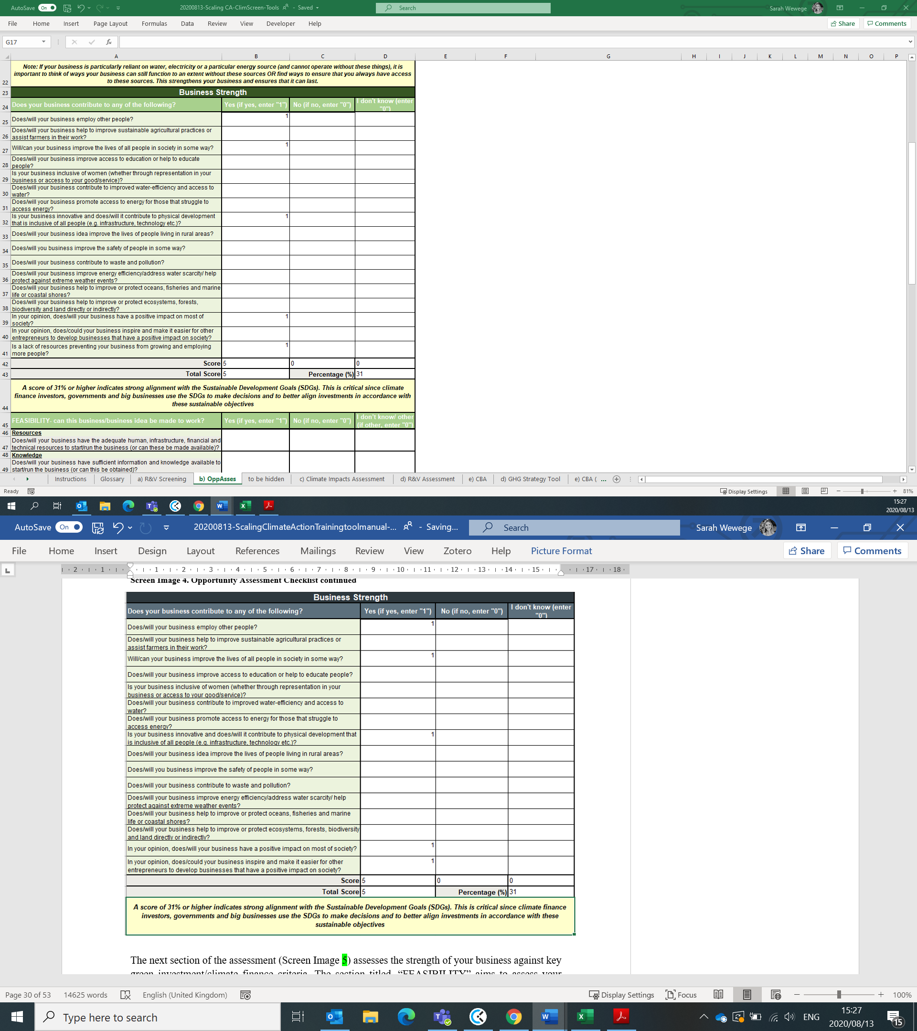
Screen Image 4. Opportunity Assessment Checklist continued

The next section of the assessment (Screen Image 5) assesses the strength of your business against key green investment/climate finance criteria. The section titled, “FEASIBILITY” aims to assess your business’s means and resources to operate while the section titled, “SUITABILITY” assesses your businesses alignment with your country’s NDCs (see Box 5 for information on your country’s NDCs-mitigation and adaptation goals) and economic goals. The sections titled, “IMPACT” and “SUSTAINABILITY” assess whether your business will have a lasting impact and if it contributes to climate change reduction. Alignment with these two sections is particularly important for being in a position to access climate financing and green investment.

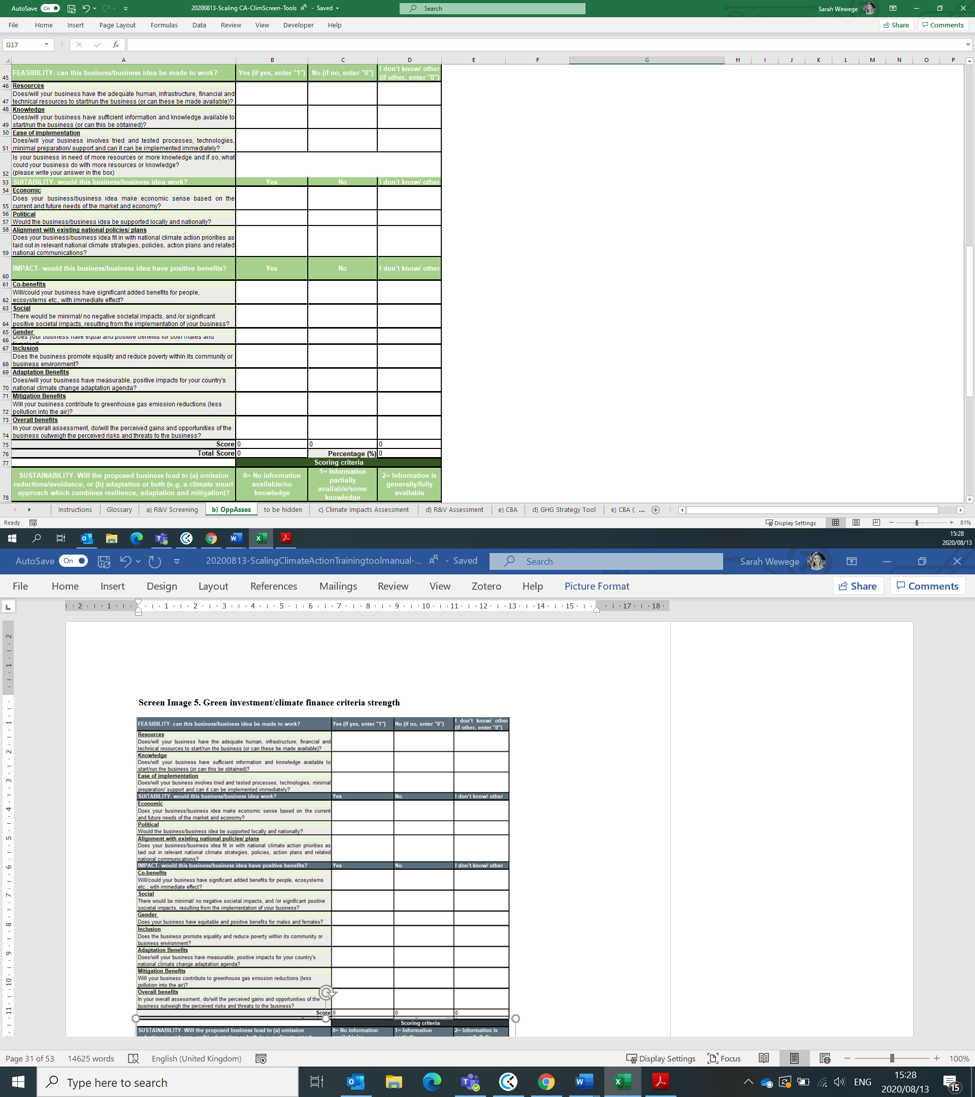
Screen Image 5. Green investment/climate finance criteria strength

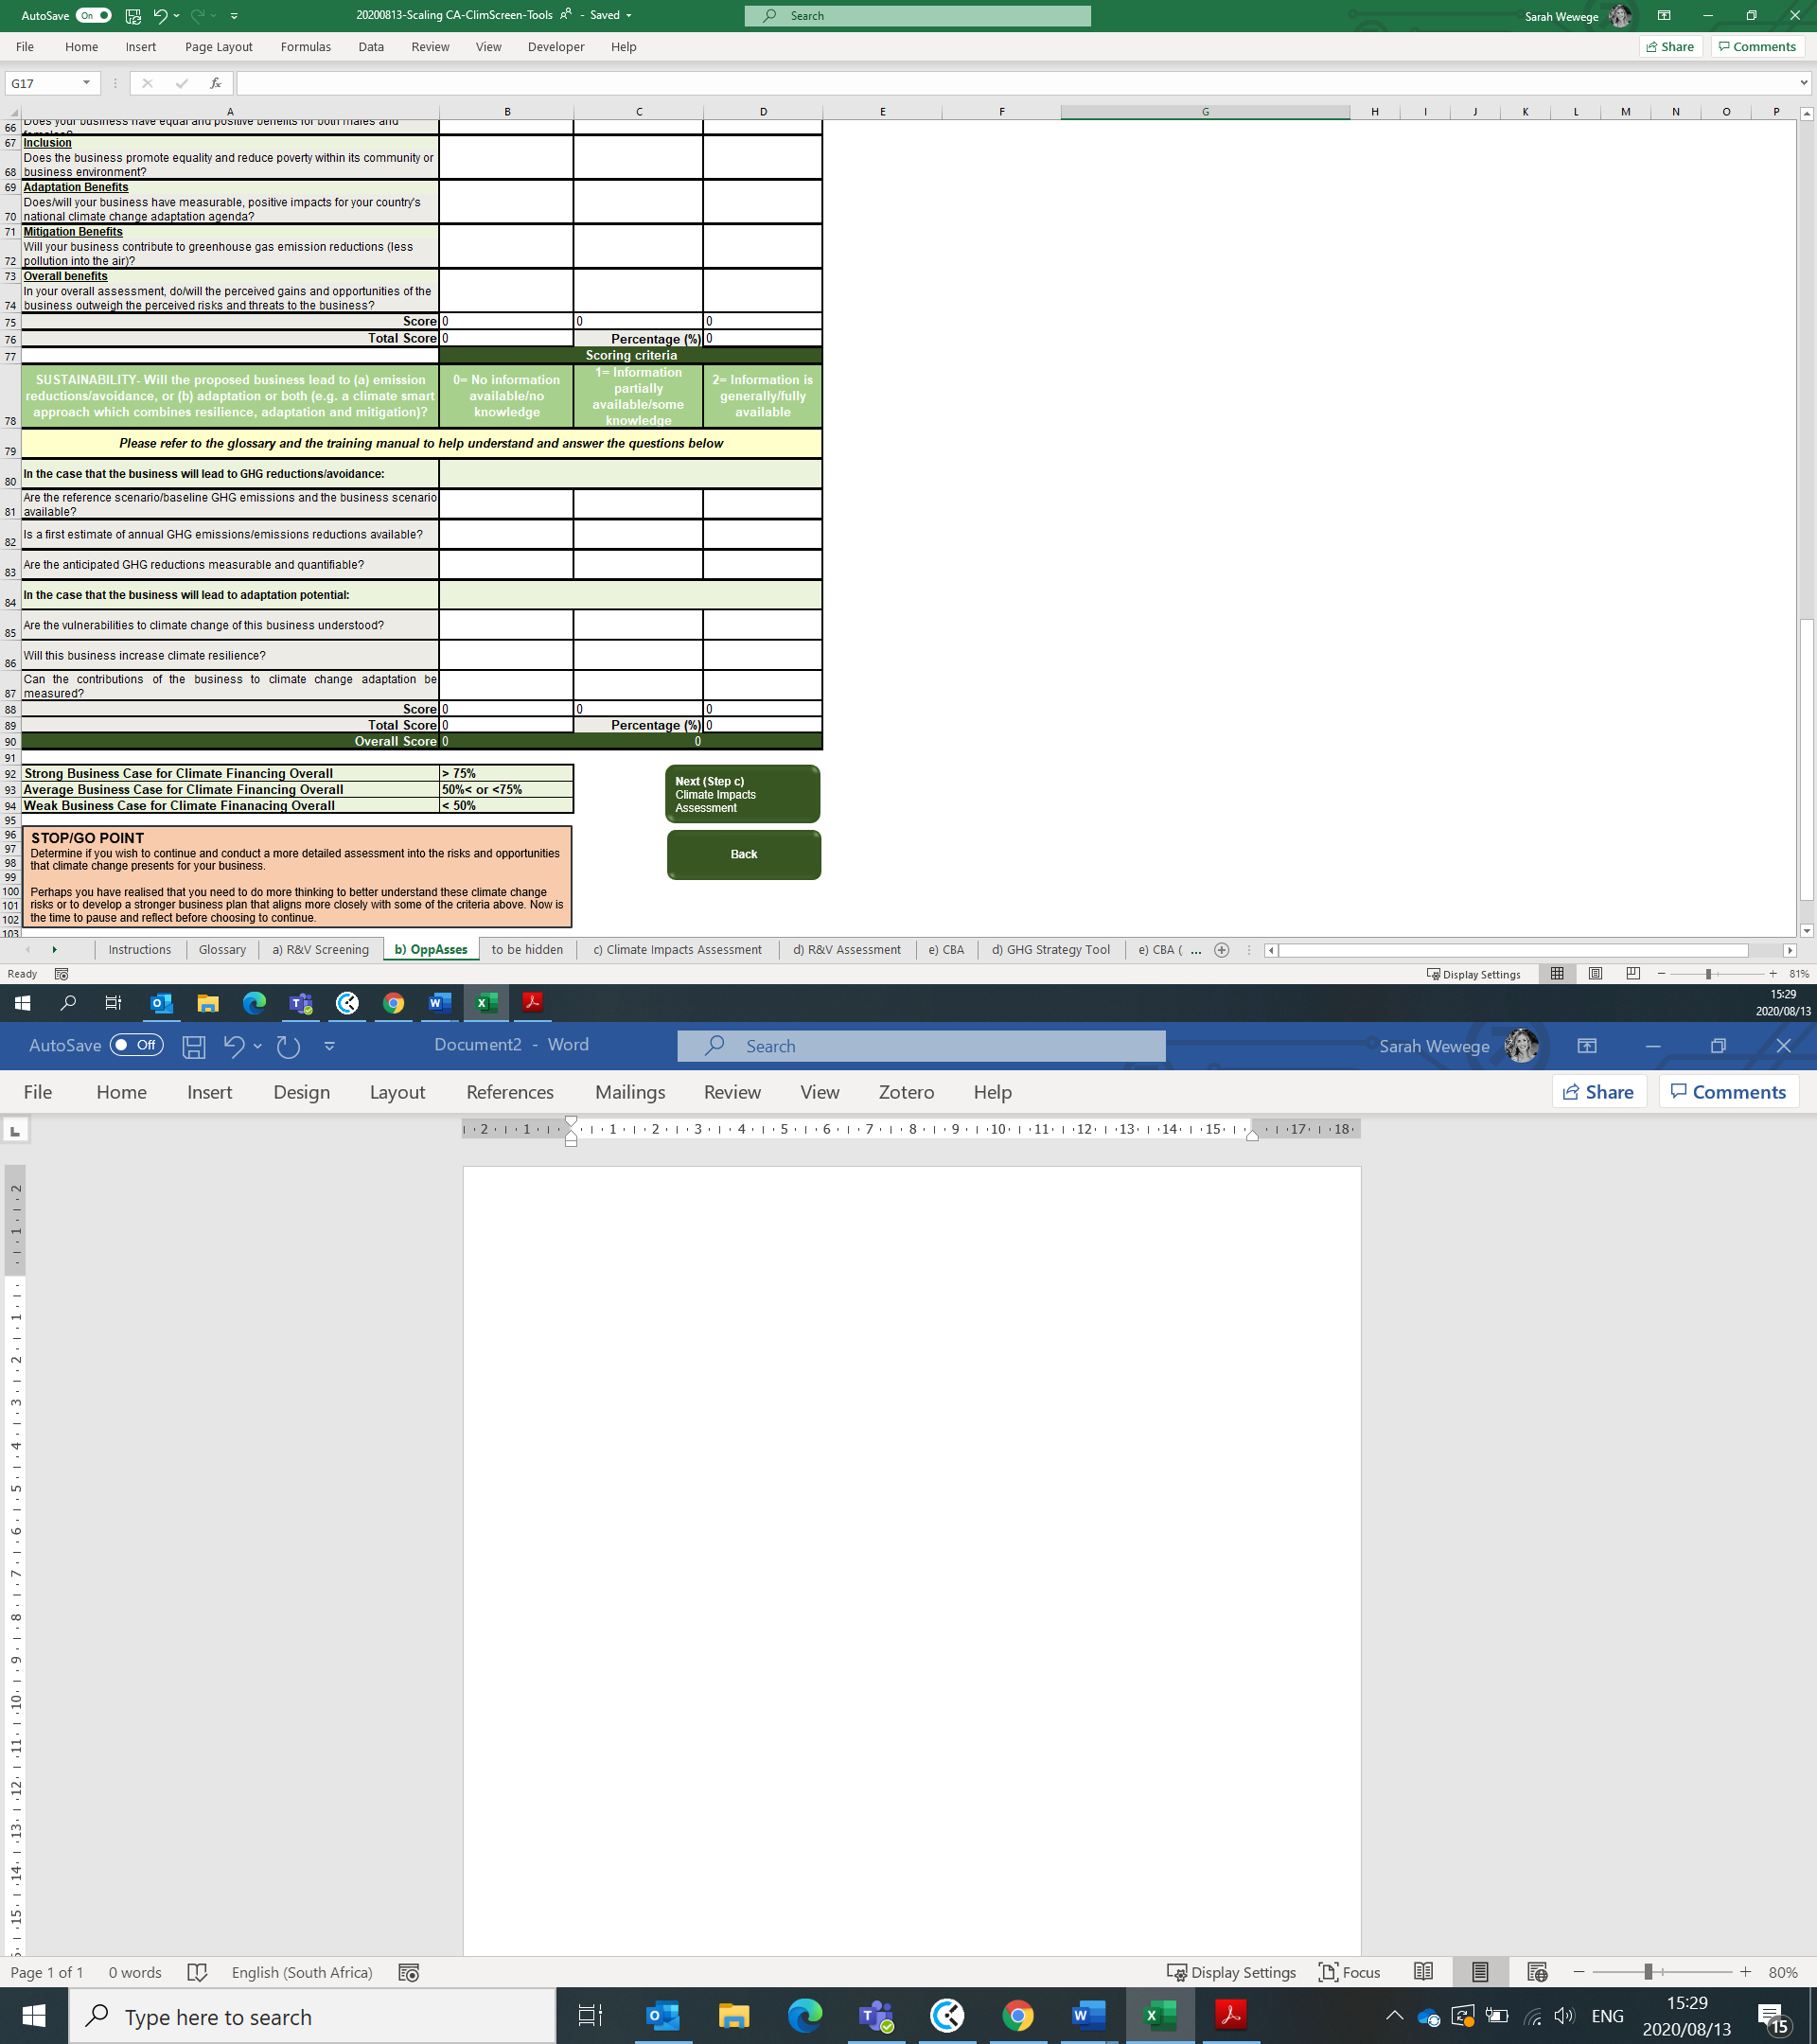

After completing this checklist, an automatic score will be generated for your business. A score over 75% indicates that you have a strong business case for accessing climate financing. A score between 50% and less than 75% indicates that you should spend more time strengthening your business case by aligning these objectives with core business objectives (see links in Box 6). A score of less than 50% indicates that your business has not considered SDGs, NDCs or other green financing criteria and therefore, further business research and development is needed.
Box 6. The importance of SDGs and NDCs for businesses
Environmental, social and governance (ESG) investment is becoming increasingly important for investors, with banking and insurance sectors looking to diversify their portfolios away from carbon-intense companies or those at high risk of deforestation (Edie, 2019). SDGs provide a universal framework for businesses to measure performance, set targets and actions, communicate to stakeholders (including investors) and access new market opportunities. Furthermore, there is a strong business case for aligning with SDGs in order to secure steady returns for investors through giving portfolios a competitive advantage (Electric, 2020).
Given that NDCs relate to the SDGs and aim to reduce climate emissions and encourage adaptation, businesses should ensure that they align with SDGs and their country’s NDCs, to maximise attractiveness for investment opportunity and ensure future competitiveness and sustainability.

Step c) Climate Impacts Assessment
The purpose of the Climate Impacts Assessment is to explore potential climate change impacts in greater detail, mapping the impacts through various steps. In essence, this process should help your business unpack how certain climate hazards such as flooding, drought, a rise in temperature etc., may have an impact on the enviornment you work in, your workplace or workers and ultimately, how this may affect your business. Understanding these risks is critical as it will help your business plan for protection and may highlight new business opportunities. Screen Image 6 shows what is called, “the 1st to 4th Impact diagram.” This shows the process of how you will think through the impacts of climate change in terms of a system or your business. For example, decreased rainfall may lead to drought which leads to a loss of crops/growth of plants. This in turn could lead to less harvest which results in less income for a farmer, perhaps a loss of jobs too as the farmer can no longer afford to keep all his/her workers.
Screen Image 6. 1st to 4th Order framework highlighting the impact of climate change
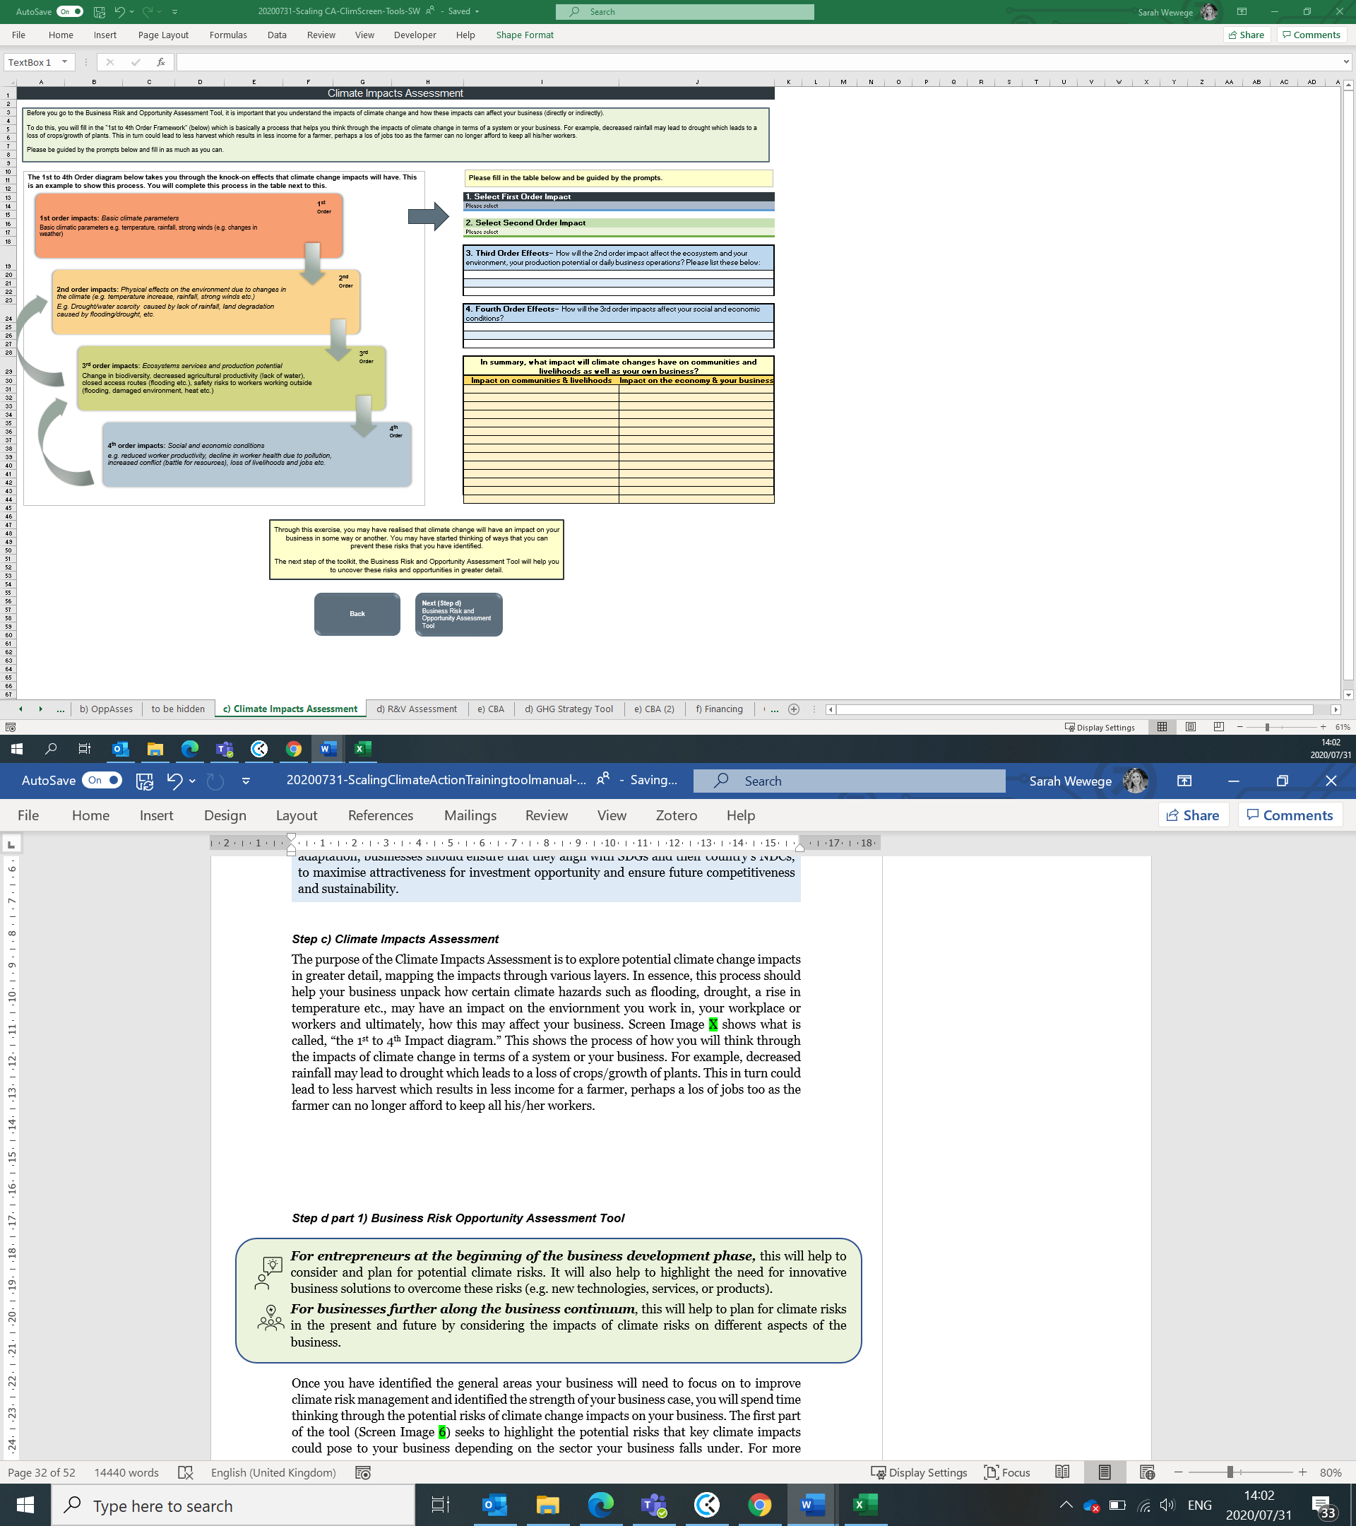

Source: Petrie et al., 2016

You will then complete this process (Screen Image 7) by selecting a “First Order Impact” from the dropdown menu such as increased temperature, increased rainfall, increased wind-speeds or sea-level rise. You will then select the corresponding “Second Order Impact” from the drop down menu (e.g. increased flooding). Thereafter you will complete the third to fourth order effects of those impacts. Third order effects are those which relate to the physical environment and surrounding ecosystems whereas fourth order effects are those which deal with social and economic effects.
Screen Image 7. Climate impacts assessment table
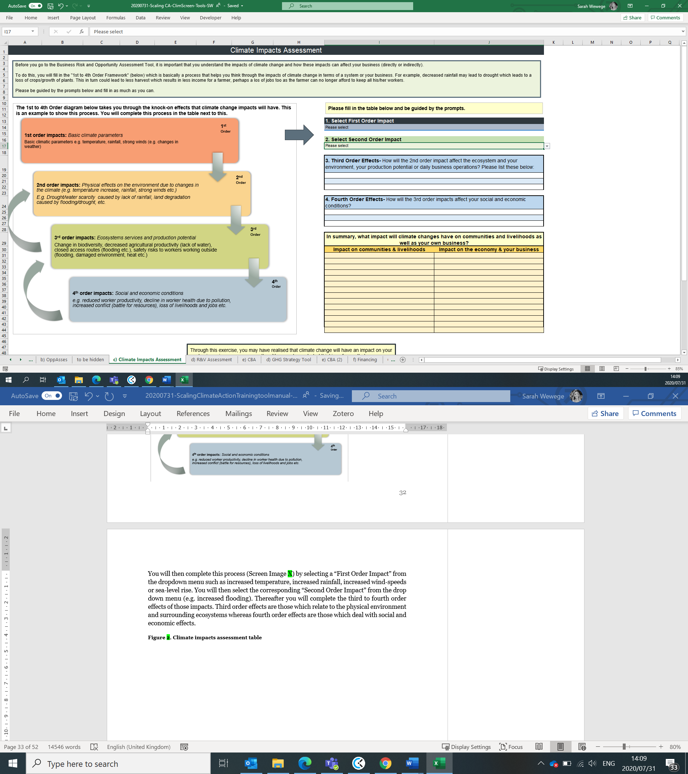

Through this exercise, you may have realised that climate change will have an impact on your business in some way or another. You may have started thinking of ways that you can prevent these risks that you have identified. The next step of the toolkit, the Business Risk and Opportunity Assessment Tool will help you to uncover these risks and opportunities in greater detail.

Step d) Business Risk Opportunity Assessment Tool
For entrepreneurs at the beginning of the business development phase, this will help to consider and plan for potential climate risks. It will also help to highlight the need for innovative business solutions to overcome these risks (e.g. new technologies, services, or products).
For businesses further along the business continuum, this will help to plan for climate risks in the present and future by considering the impacts of climate risks on different aspects of the business.



Once you have identified the general areas your business will need to focus on to improve climate risk management and identified the strength of your business case, you will spend time thinking through the potential risks of climate change impacts on your business. The first part of the tool (Screen Image 8) seeks to highlight the potential risks that key climate impacts could pose to your business depending on the sector your business falls under. For more information on the risks that climate change could have on your business, seethe “Business Risks, Opportunities and Leadership” report by the Centre for Climate and Energy Solutions (C2ES, 2019):
https://www.c2es.org/site/assets/uploads/2019/04/business-risks-opportunities-and-leadership.pdf).
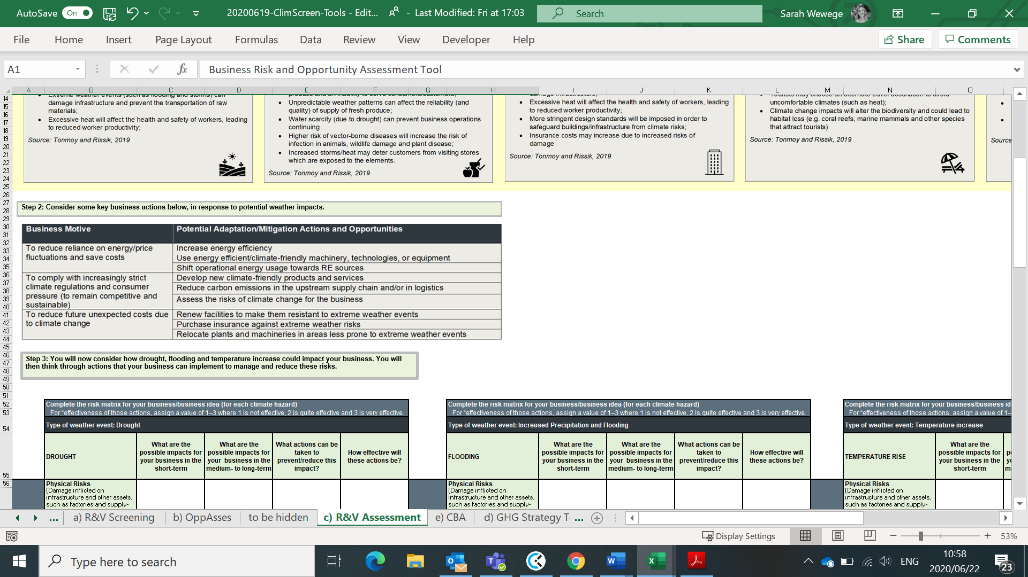
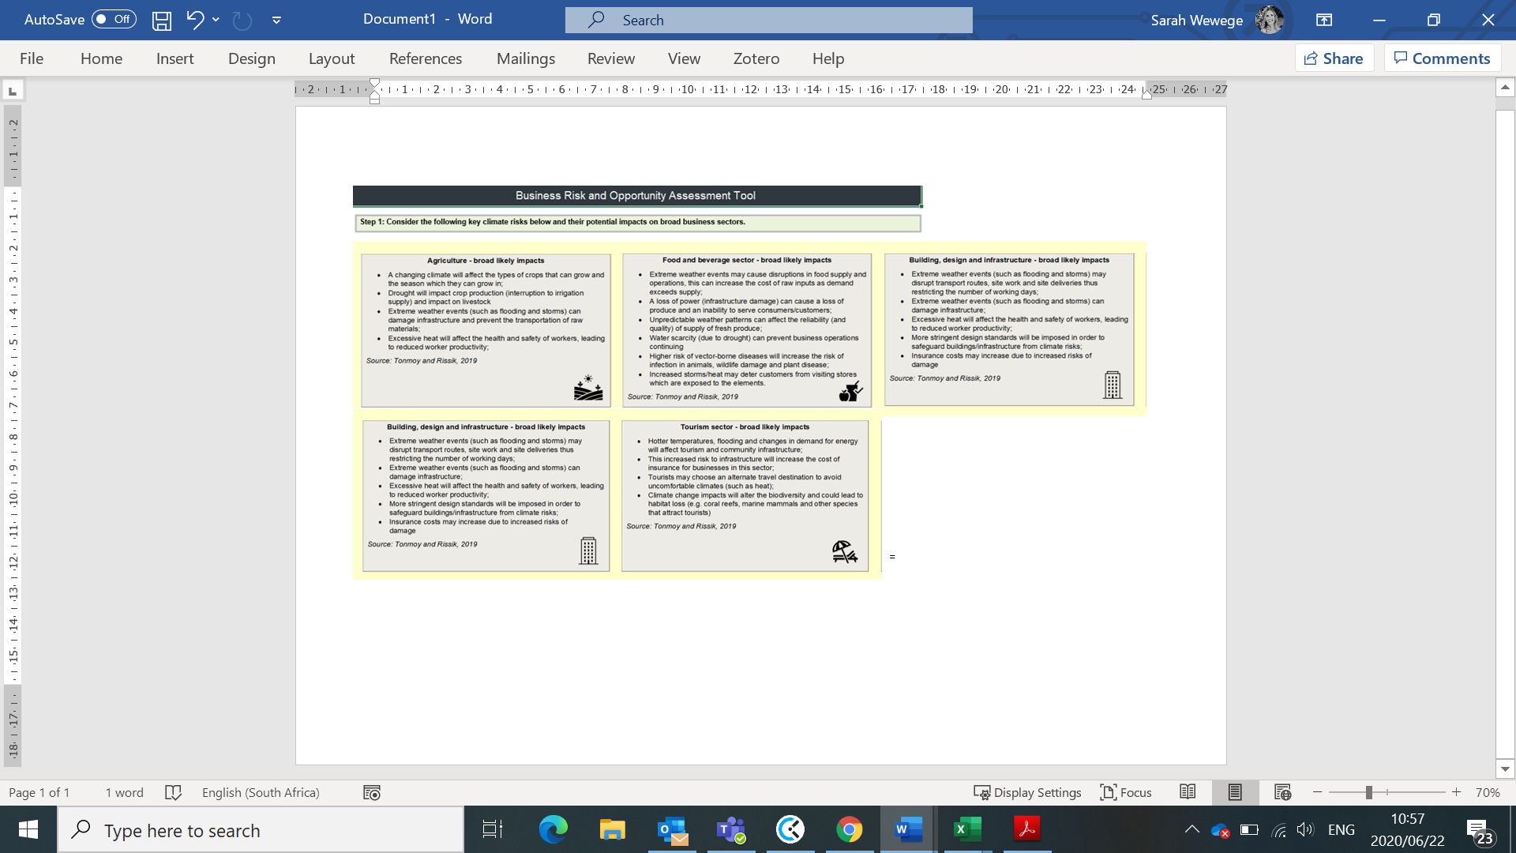
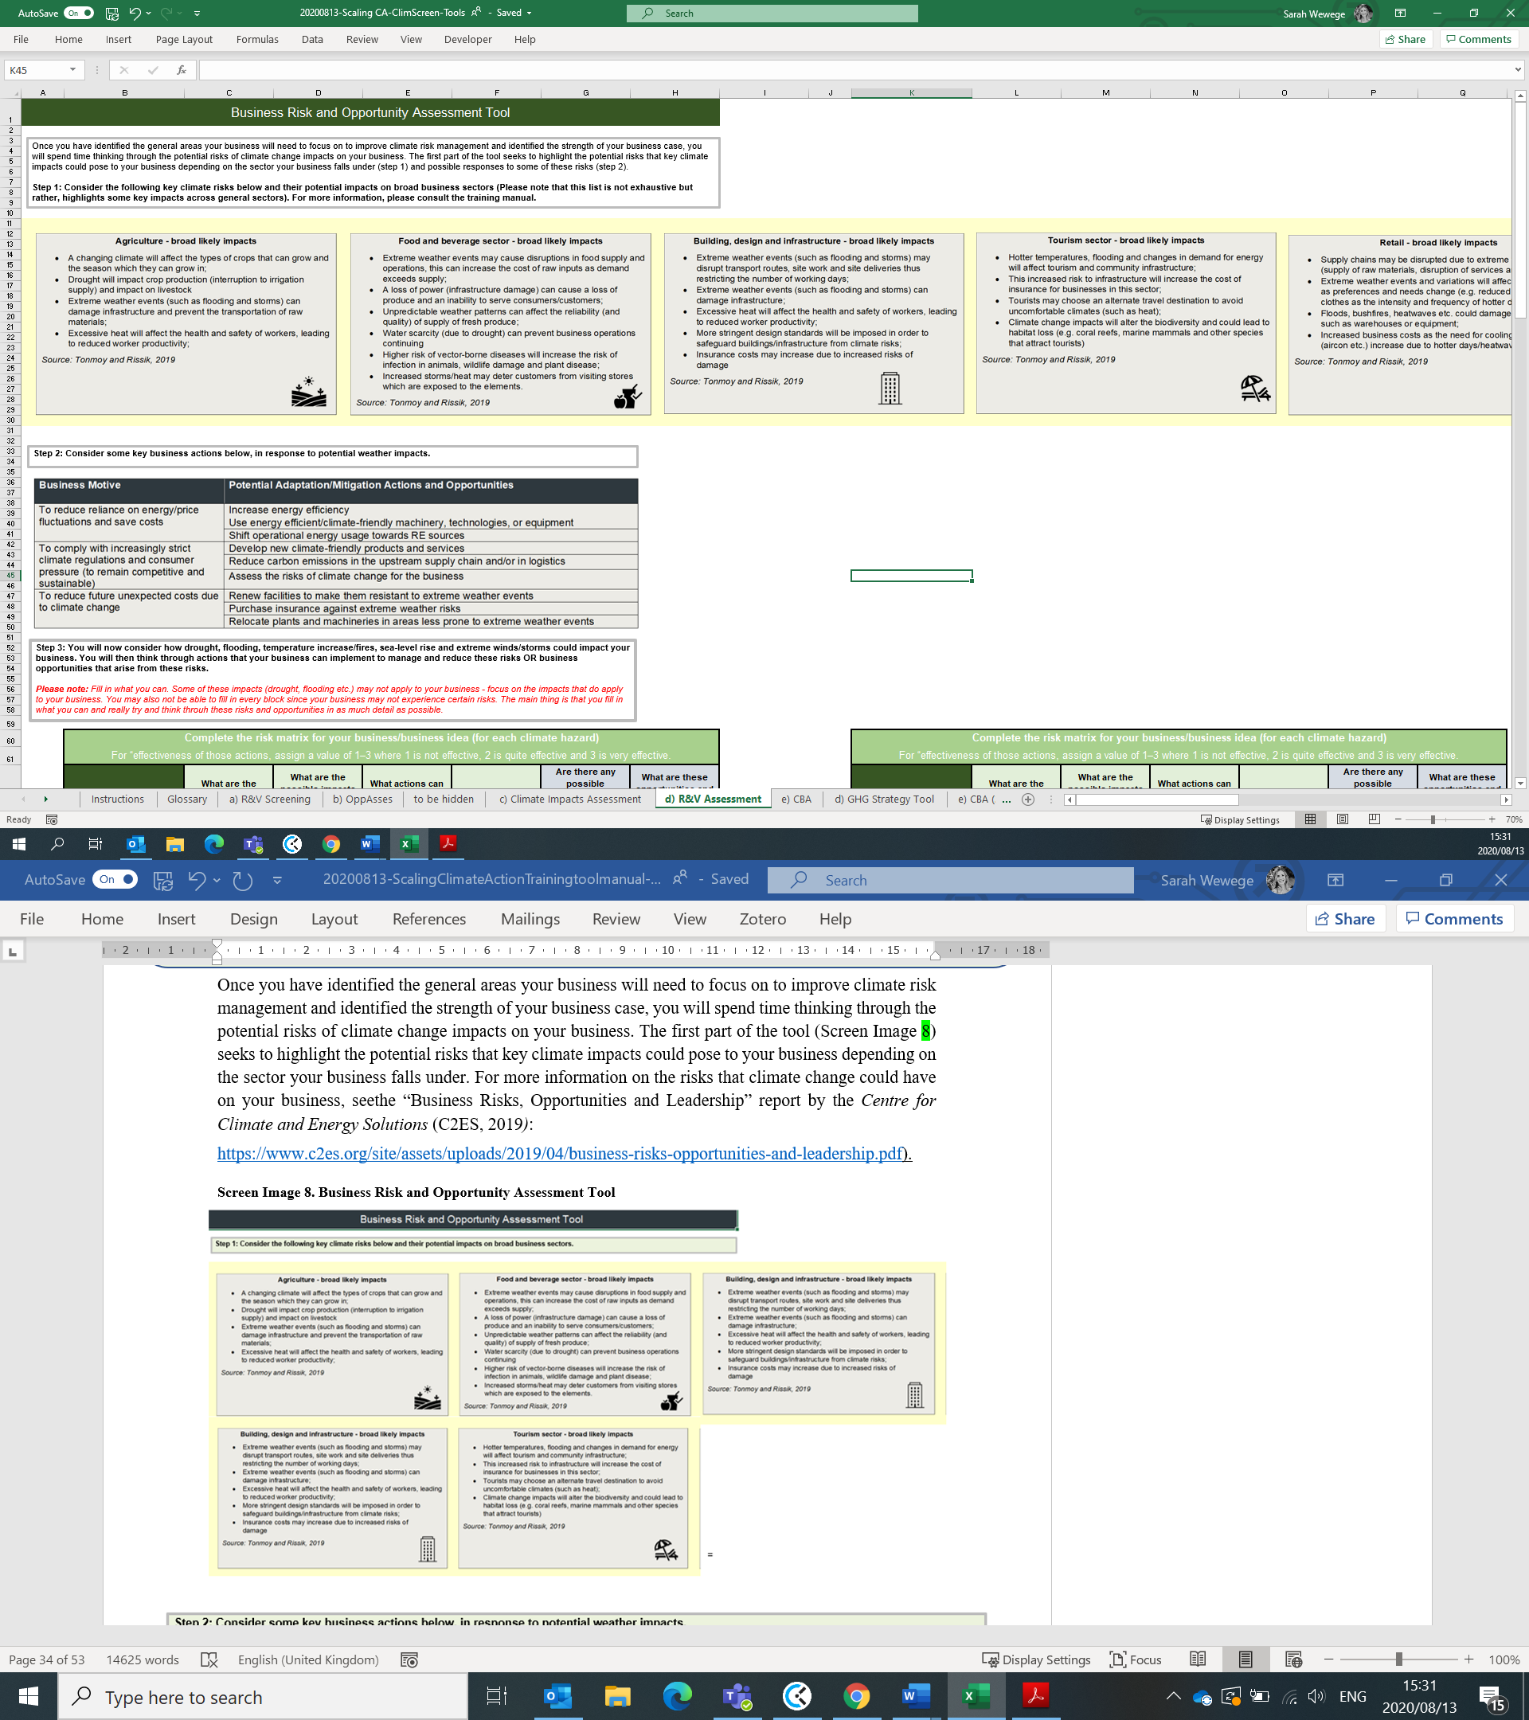
Screen Image 8. Business Risk and Opportunity Assessment Tool

The second part of the tool (Screen Image 9) requires you to think through the key climate impacts (drought, flooding, temperature rise, sea-level rise and extreme wind speeds) on various aspects of your business (value-chain and external stakeholder risks). Value-chain risks pose risks to the physical, day-to-day operational aspects of your business whilst external stakeholder risks, such as reputation and regulation, will make it difficult to do business overall and in the long-term. It is important that you consider the risks to each of these areas in order to implement actions to mitigate or reduce these risks.

Screen Image 9. Business Risk and Opportunity Assessment Tool continued

Through this exercise, you may also realise that many other businesses face similar risks and in turn, come up with a business idea (opportunity) that will help other businesses overcome this risk; or, you may discover opportunities for your business to contribute to climate change mitigation.
The final part of this tool (Screen Image 10) requires that you rank the key climate threats listed according to:
- Likelihood of the threat affecting your business
- Consequence on the business should the threat occur
Ranking these threats according to the above criteria will help to determine the potential risks to your business in the present and future scenarios.
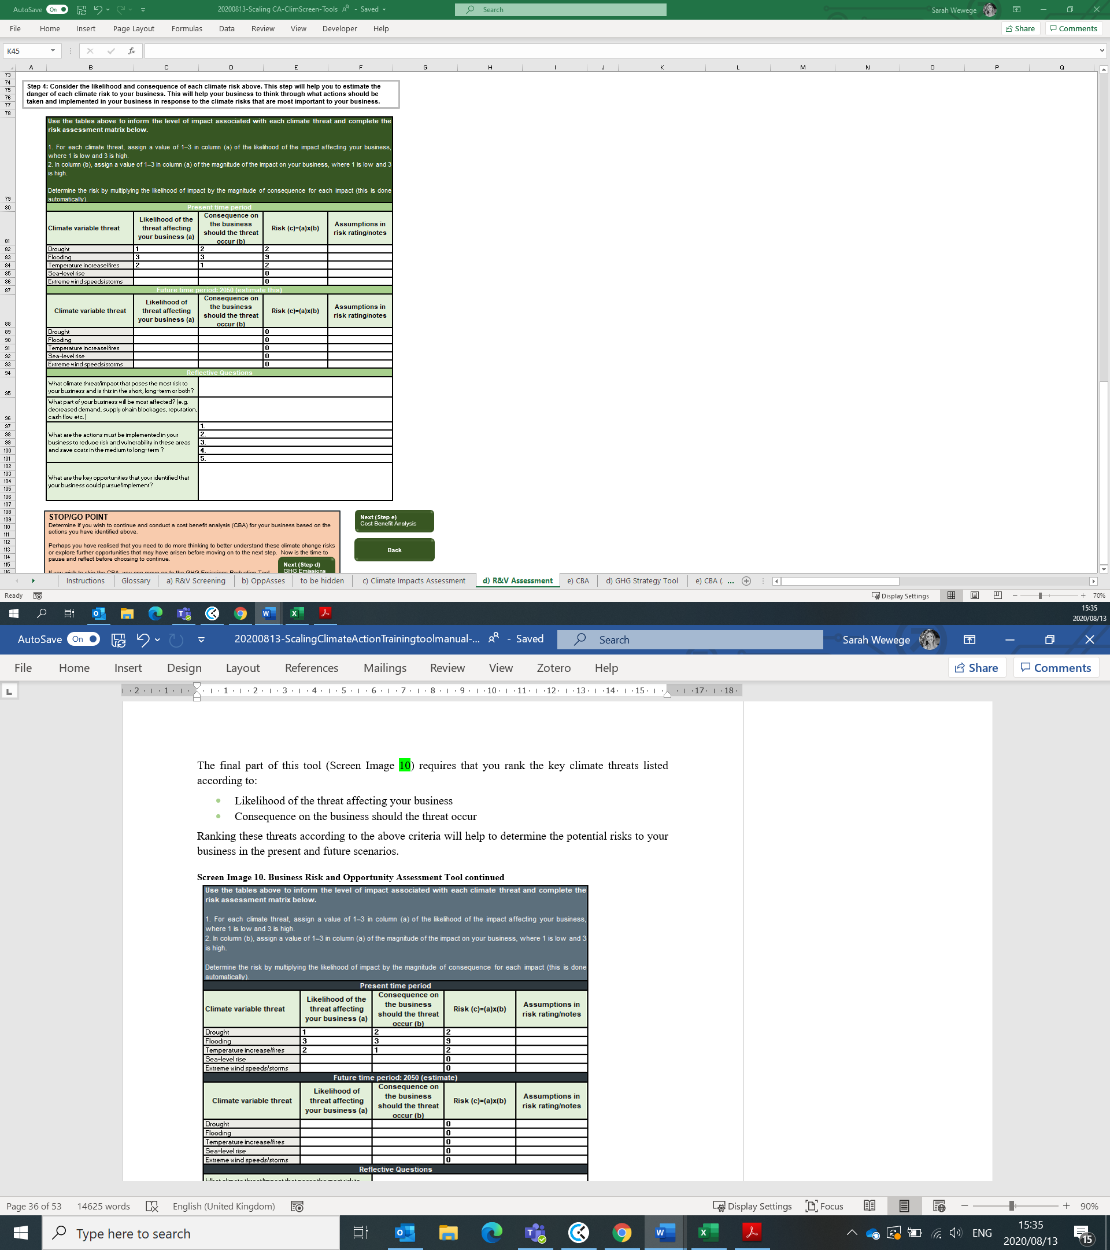
Screen Image 10. Business Risk and Opportunity Assessment Tool continued

Once you have determined the potential risks to your business in the present and future period, you are able to actionable items that must be implemented in order to overcome and mitigate against these risks OR key opportunities that your business may wish to pursue. Some potential actions are listed in the first part of this tool (Screen Image 8). You will then process to step e, the cost benefit analysis (see step e).

Step e) Cost Benefit Analysis Tool
Once you have identified potential actions to help mitigate and overcome climate risks to your business (Business Risk and Opportunity Assessment Tool), it is important that you assess the costs and benefits of those actions in order to determine what is feasible to implement. The cost-benefit tool (step e) will help guide you through this process.
The purpose of this tool is to establish a general cost-benefit estimate to make informed decisions for your business. While having accurate cost estimates will prove useful and allow for a more accurate cost-benefit analysis, this is not necessary. The steps below will guide you through the process with built in formulae to ensure an easy to use tool that will help your business make decisions on what actions to implement.
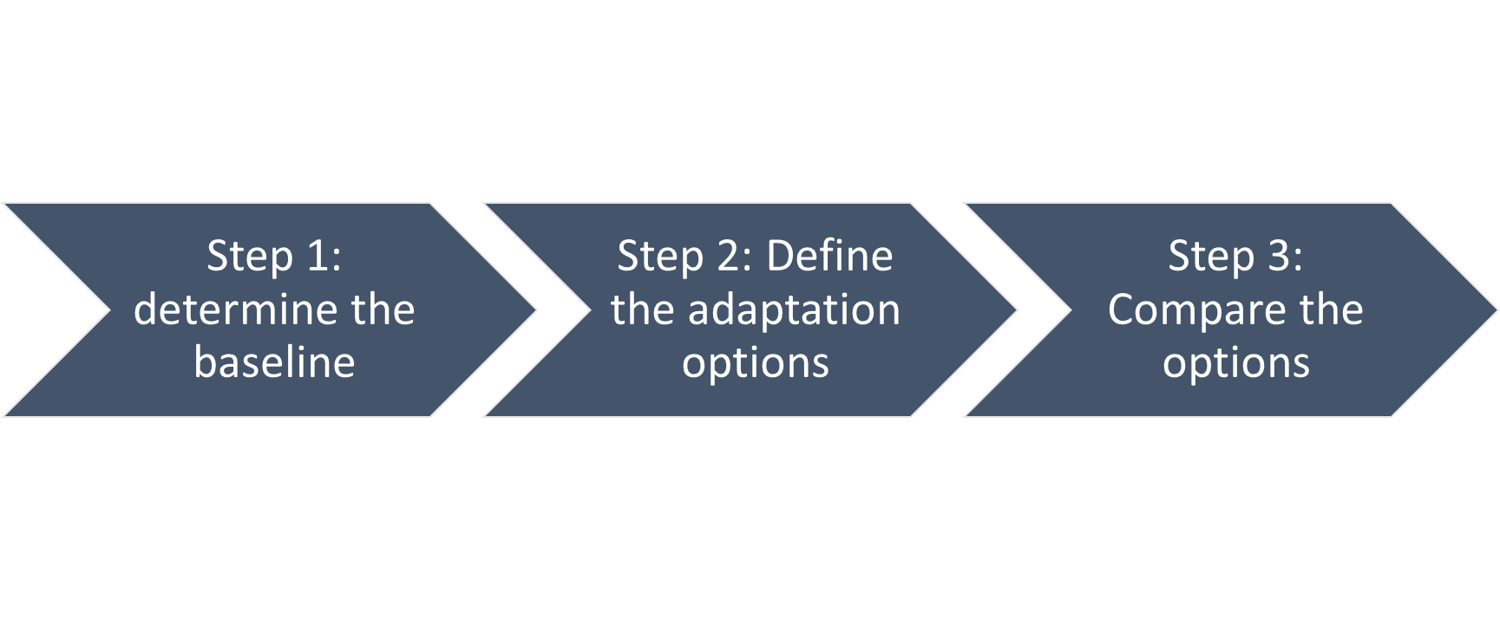

Step 1 will ask you to input the average cost of the biggest climate risk to your business per annum (Screen Image 11).
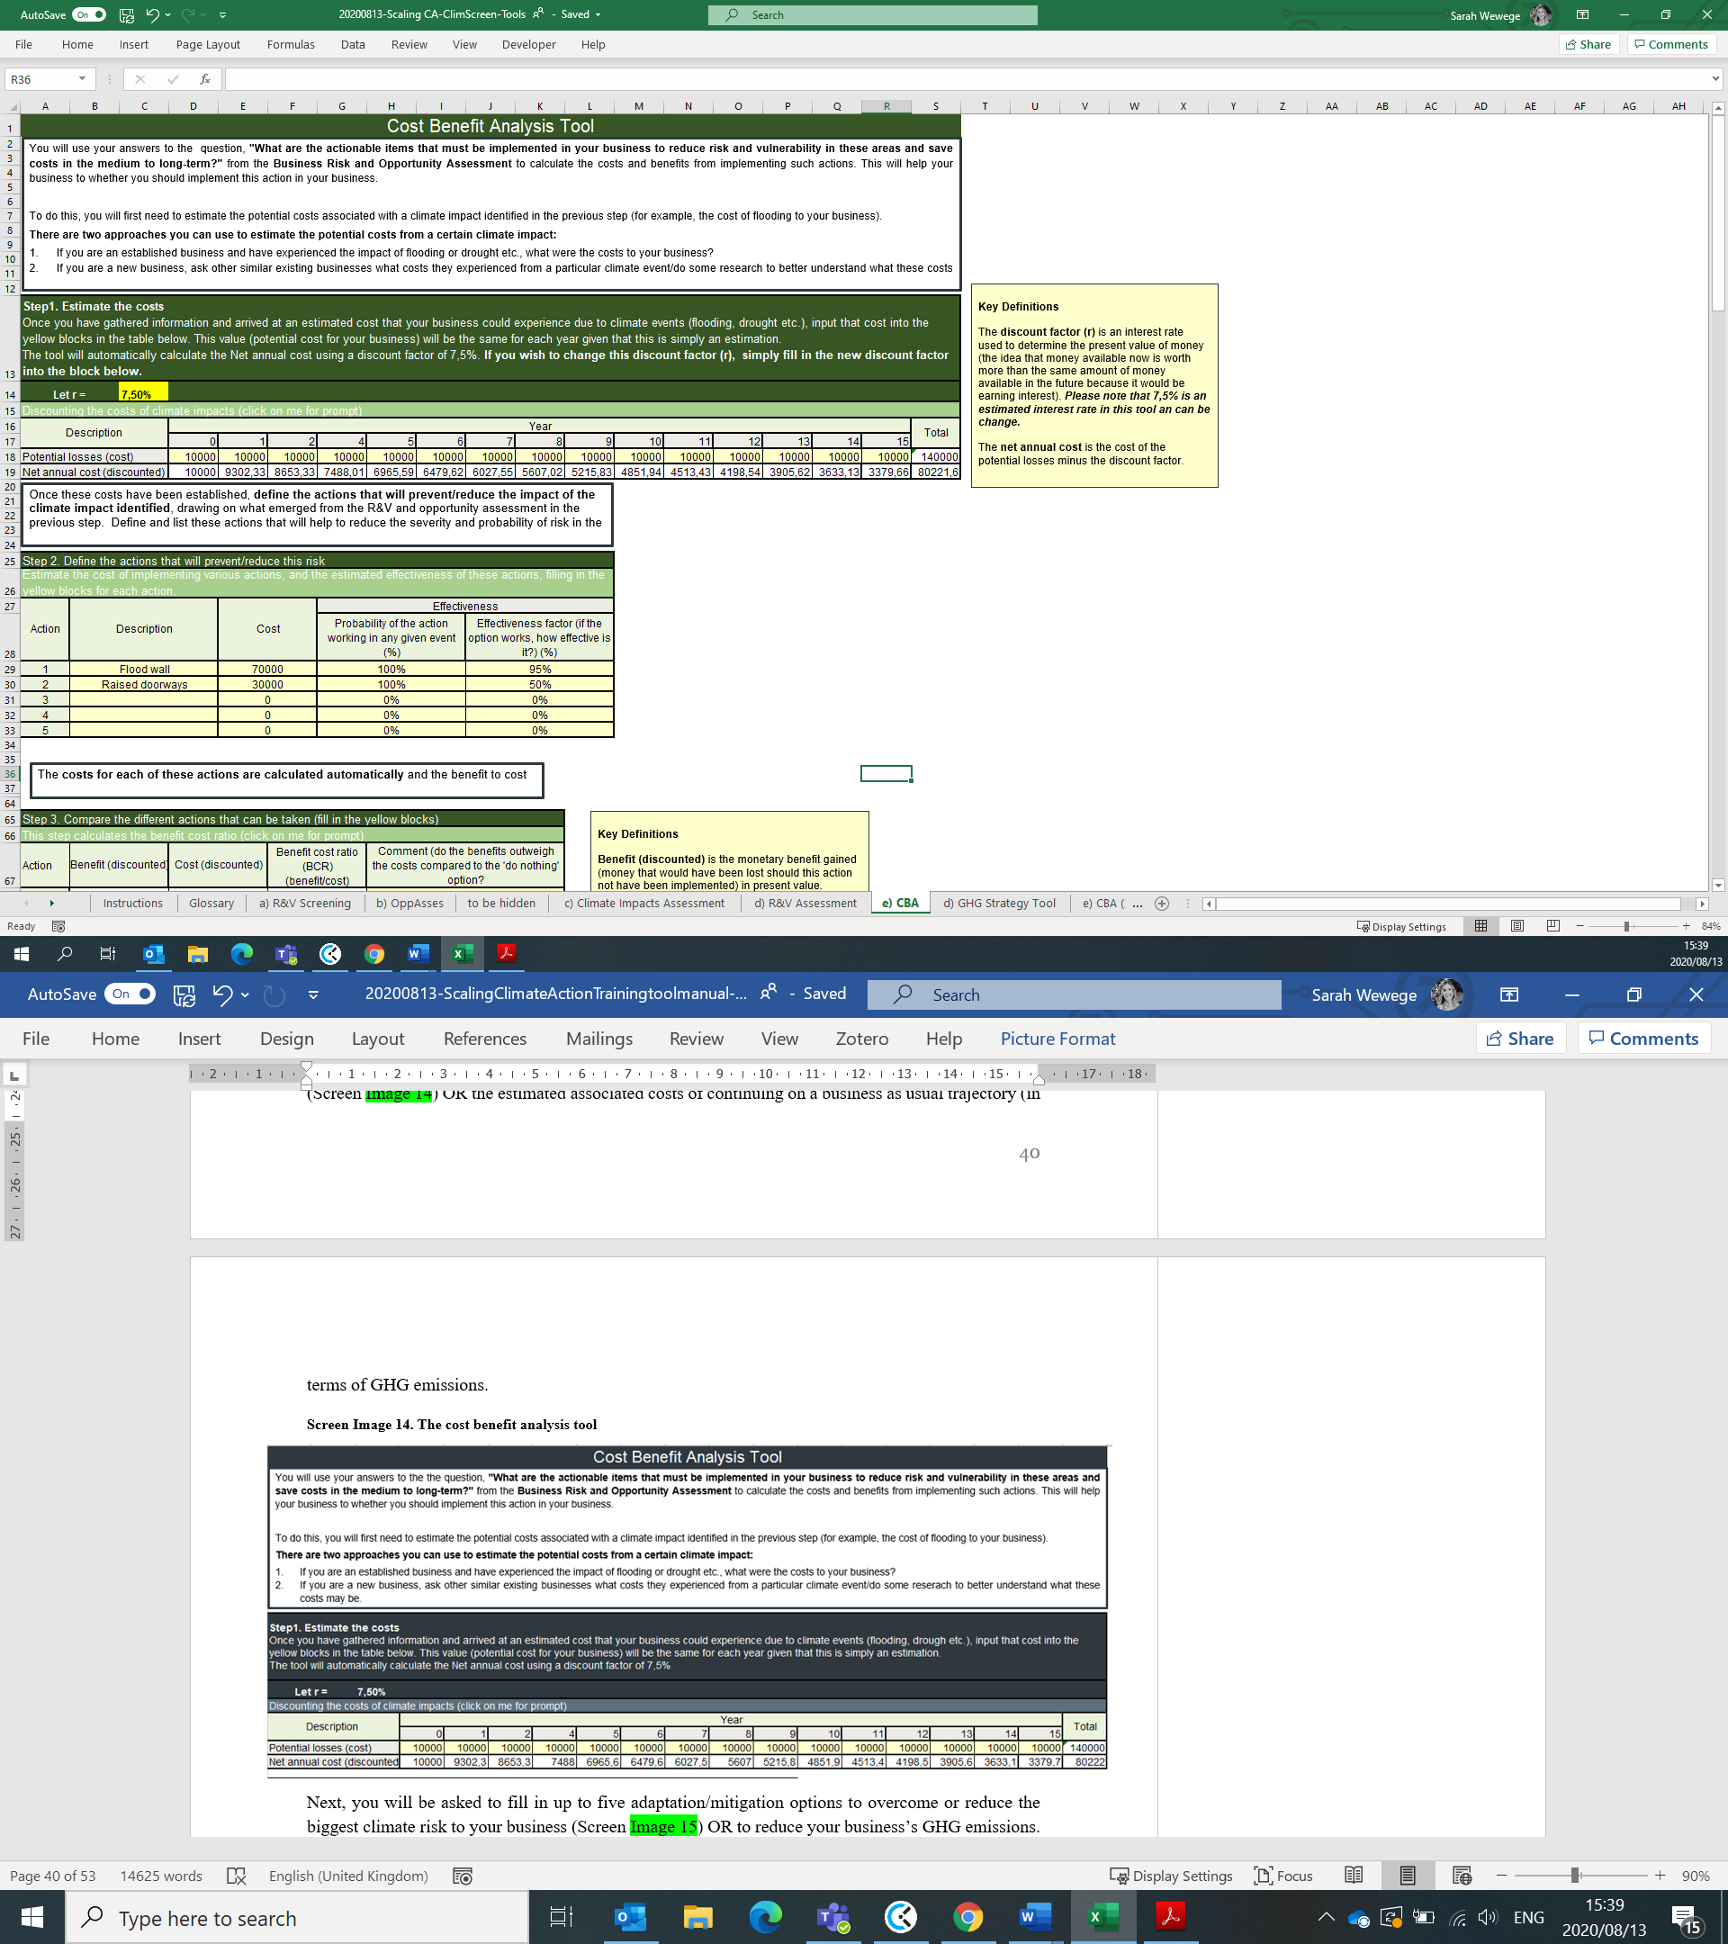
Screen Image 11. The cost benefit analysis tool
Next, you will be asked to fill in up to five adaptation/mitigation options to overcome or reduce the biggest climate risk to your business (Screen Image 12). Using this information, the tool will automatically calculate the residual cost of risk (per annum) and the net present value (NPV) of your proposed investment/action over a 15-year period.
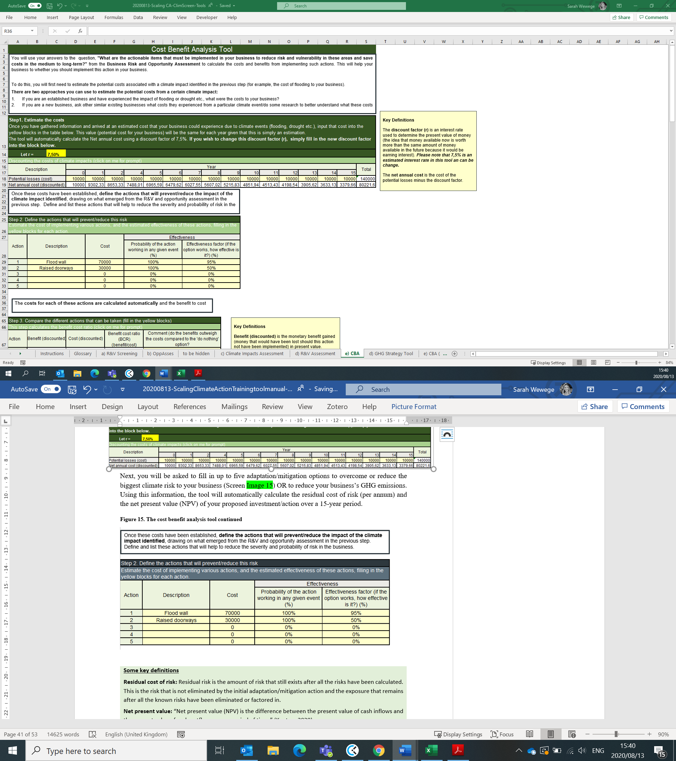
Screen Image 12. The cost benefit analysis tool continued

Some key definitions
Residual cost of risk: Residual risk is the amount of risk that still exists after all the risks have been calculated. This is the risk that is not eliminated by the initial adaptation/mitigation action and the exposure that remains after all the known risks have been eliminated or factored in.
Net present value: “Net present value (NPV) is the difference between the present value of cash inflows and the present value of cash outflows over a period of time.” (Kenton, 2020)

The next step (Screen Image 13) will be to calculate and compare the different adaptation/mitigation options OR, GHG emission reduction strategies, against the baseline (the cost of the risk/do nothing scenario) by highlighting the benefit cost ratio (BCR) of each adaptation/mitigation option. Should the BCR be greater than 1, the baseline, then it is clear that this is a beneficial action to implement.
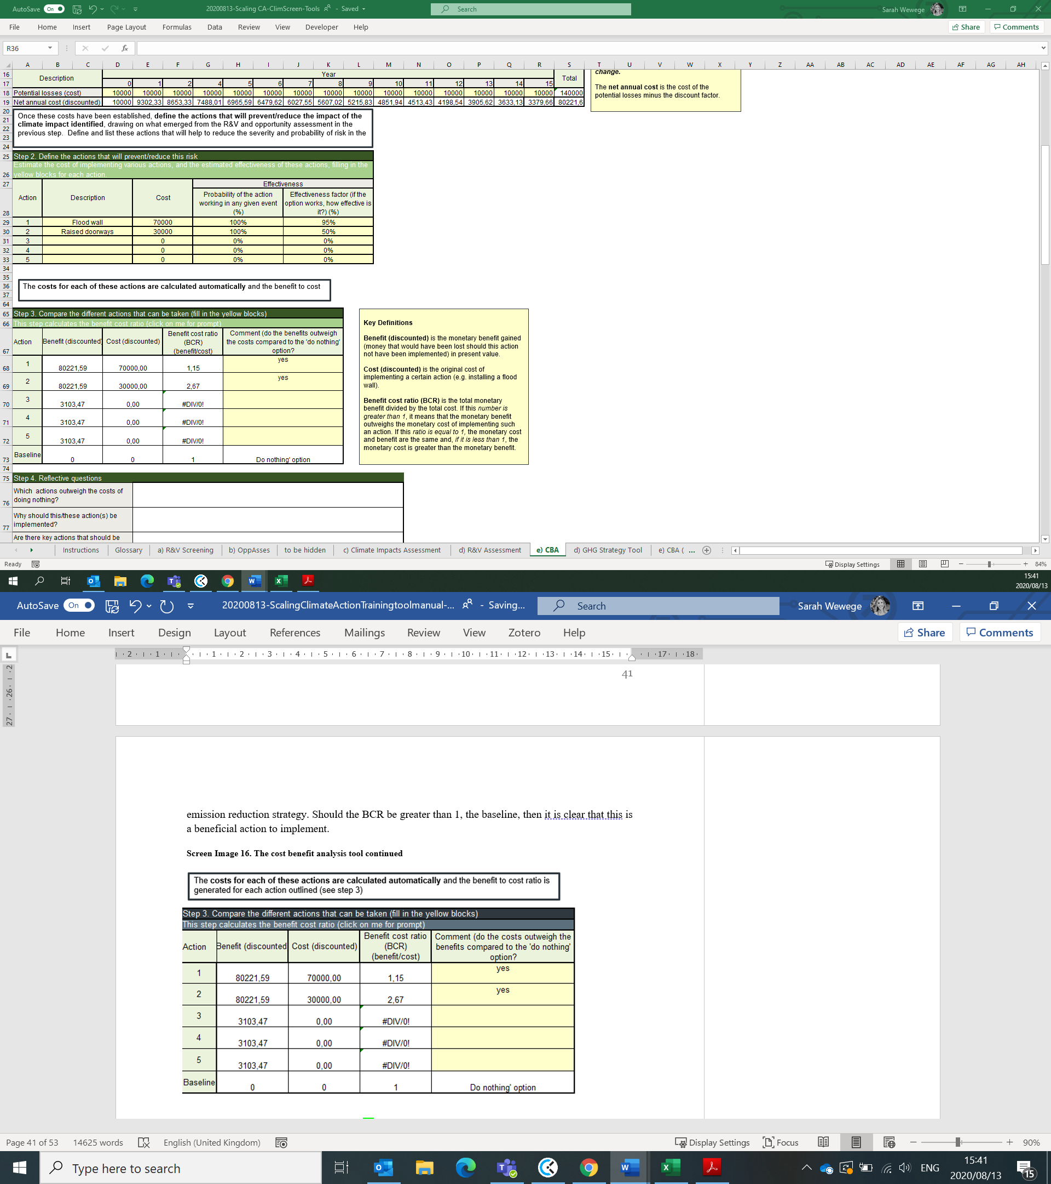
Screen Image 13. The cost benefit analysis tool continued

The last part of the tool (Screen Image 14) will then guide you through a series of questions to help establish which of the adaptation/mitigation actions to implement or not. In some cases, there may be a few actions with a BCR>1 however, not all may be financially feasible for the business. Alternatively, some adaptation/mitigation actions may have a BCR<1 yet still be implemented since the societal and reputational benefits outweigh the costs. It is important to note that this tool can only account for the estimated financial costs and benefits and is unable to account for the societal and reputational benefits and costs. To help you think through the non-financial benefits, ask yourself if these actions will help to improve the following:
- Employee health
- Employee safety and therefore, decreased insurance premiums
- Productivity
- Business reputation
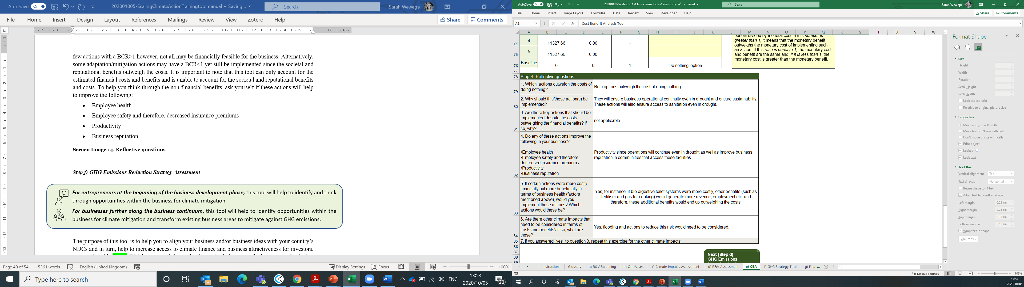
Screen Image 14. Reflective questions

Step f) GHG Emissions Reduction Strategy Assessment
For entrepreneurs at the beginning of the business development phase, this tool will help to identify and think through opportunities within the business for climate mitigation
For businesses further along the business continuum, this tool will help to identify opportunities within the business for climate mitigation and transform existing business areas to mitigate against GHG emissions.

The purpose of this tool is to help you to align your business and/or business ideas with your country’s NDCs and in turn, help to increase access to climate finance and business attractiveness for investors. As mentioned in Box 6, ESG investment is becoming increasingly important for investors and reducing your businesses GHG emissions is one way of decreasing its carbon footprint and positioning it as an attractive investment option for potential financiers. Module 3 highlights the importance of considering and implementing GHG emission reduction strategies in your business.
In excel, you will complete the GHG Emissions Reduction Strategy Assessment. The first part of the tool (Screen Image 14 below), provides instructions and information on the different types of scope/classifications for GHG emissions.
Screen Image 14. GHG Emissions Reduction Strategy Assessment
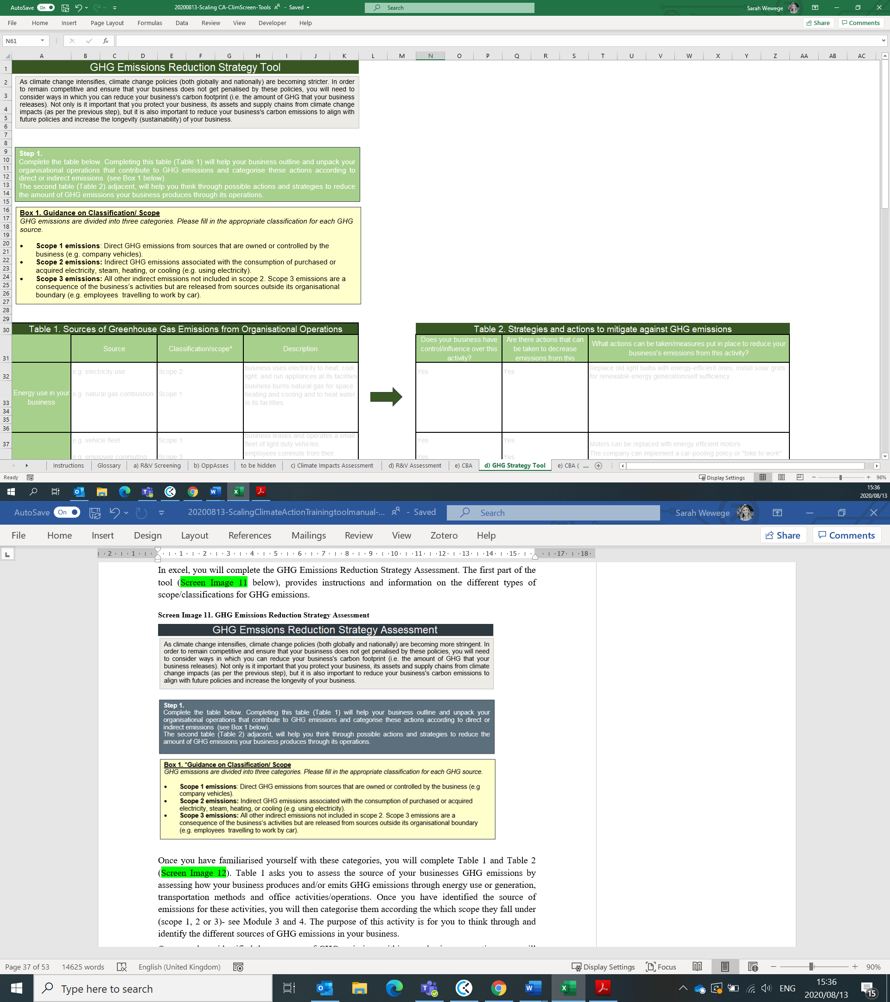

Once you have familiarised yourself with these categories, you will complete Table 1 and Table 2 (Screen Image 15). Table 1 asks you to assess the source of your businesses GHG emissions by assessing how your business produces and/or emits GHG emissions through energy use or generation, transportation methods and office activities/operations. Once you have identified the source of emissions for these activities, you will then categorise them according the which scope they fall under (scope 1, 2 or 3)- see Module 3 and 4. The purpose of this activity is for you to think through and identify the different sources of GHG emissions in your business.
Once you have identified these sources of GHG emissions within your business operations, you will then complete Table 2 (Screen Image 15) which helps you to identify opportunities within your control to decrease your businesses carbon footprint. By thinking through the aspects of your business that you control, you can come up with ways to reduce your GHG emissions through implementing key actions.

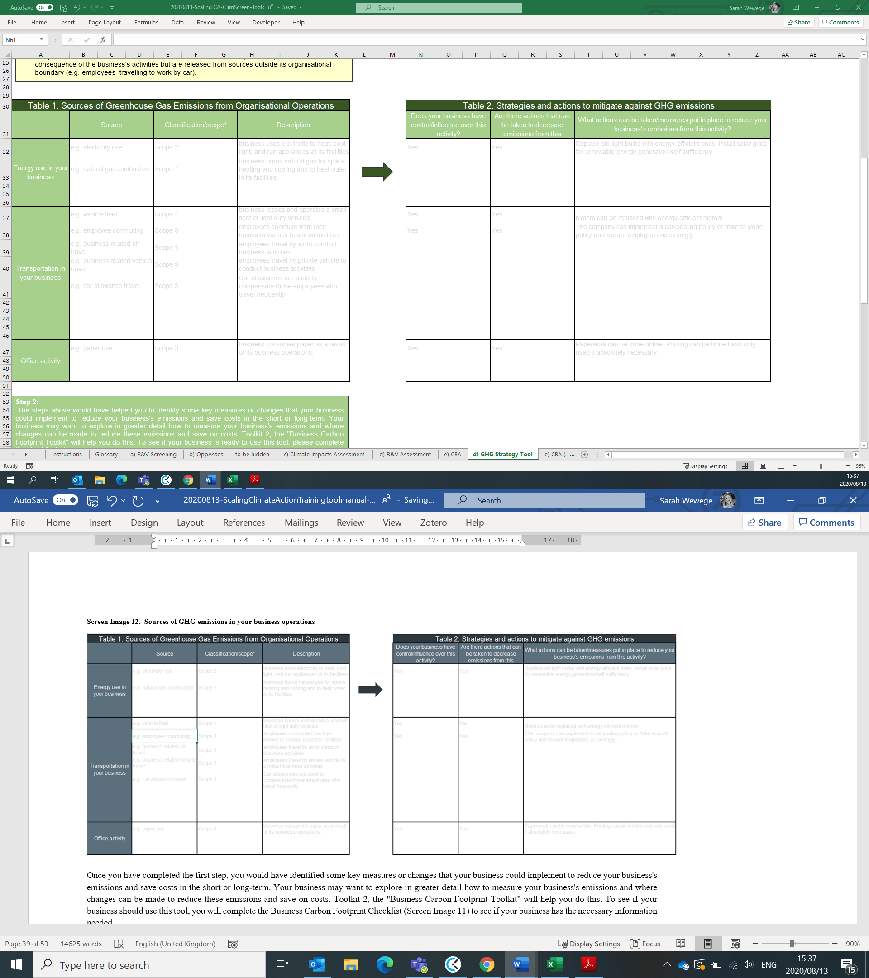
Screen Image 15. Sources of GHG emissions in your business operations

Once you have completed the first step, you would have identified some key measures or changes that your business could implement to reduce your business's emissions and save costs in the short or long-term. Your business may want to explore in greater detail how to measure your business's emissions and where changes can be made to reduce these emissions and save on costs. Toolkit 2, the "Business Carbon Footprint Toolkit" will help you do this. To see if your business should use this tool, you will complete the Business Carbon Footprint Checklist (Screen Image 11) to see if your business has the necessary information needed.
The final part of this tool ( Screen Image 16) requires that you rank the key actionable items that your business should implement (from the first step) to reduce GHG emissions and consequently, your business’s financial and reputational risk.
Screen Image 16. Establishing a GHG baseline
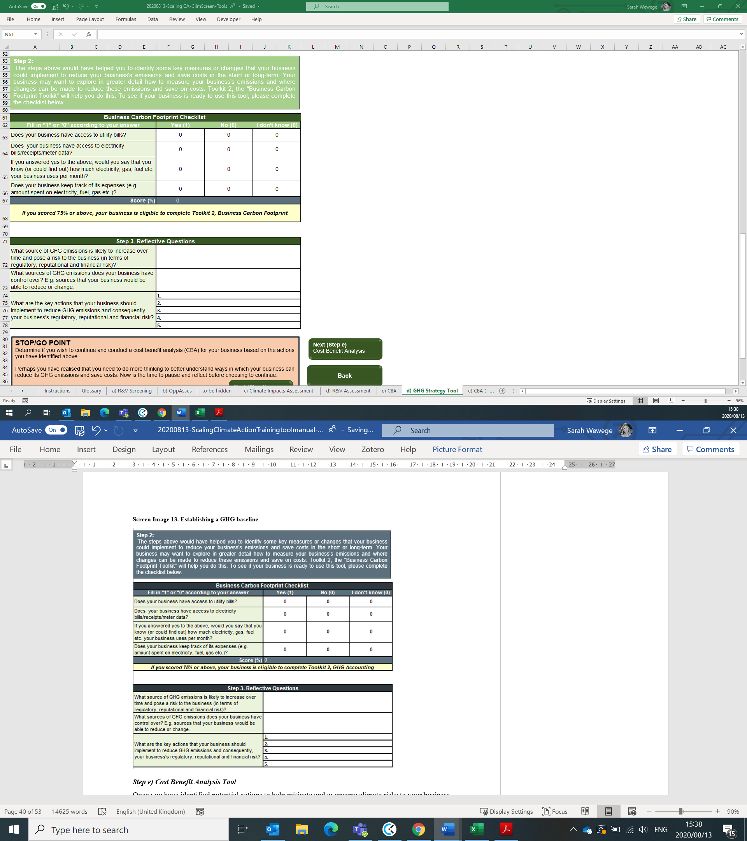

Step f) Financing Opportunity Checklist
In the last step of this toolkit, you will complete a financing checklist (Screen Image 17) to assess how ‘finance-ready’ your business is. This financing checklist consists of general criteria that climate financiers (as well as general financiers) look for. Thus, it provides gudinace on the types of documents an dinformation needed, as well as helping you think through your business impact. If you are able to answer “yes” to most- all of the questions, your business is well-placed to receive climate financing.
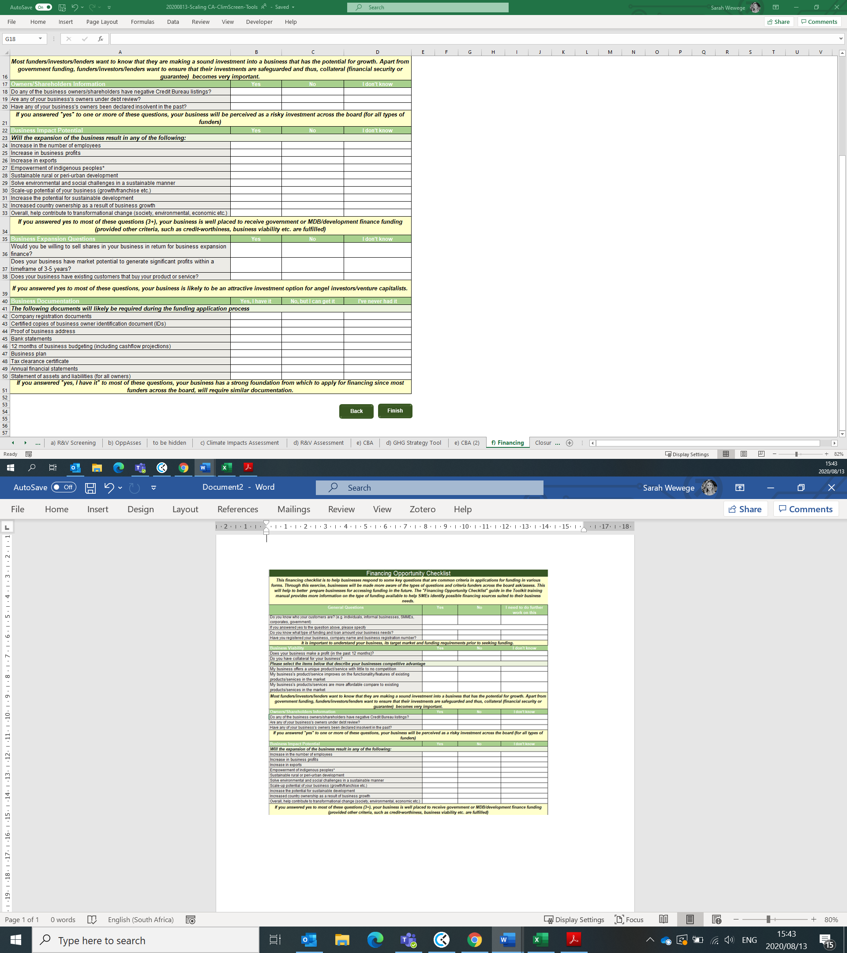
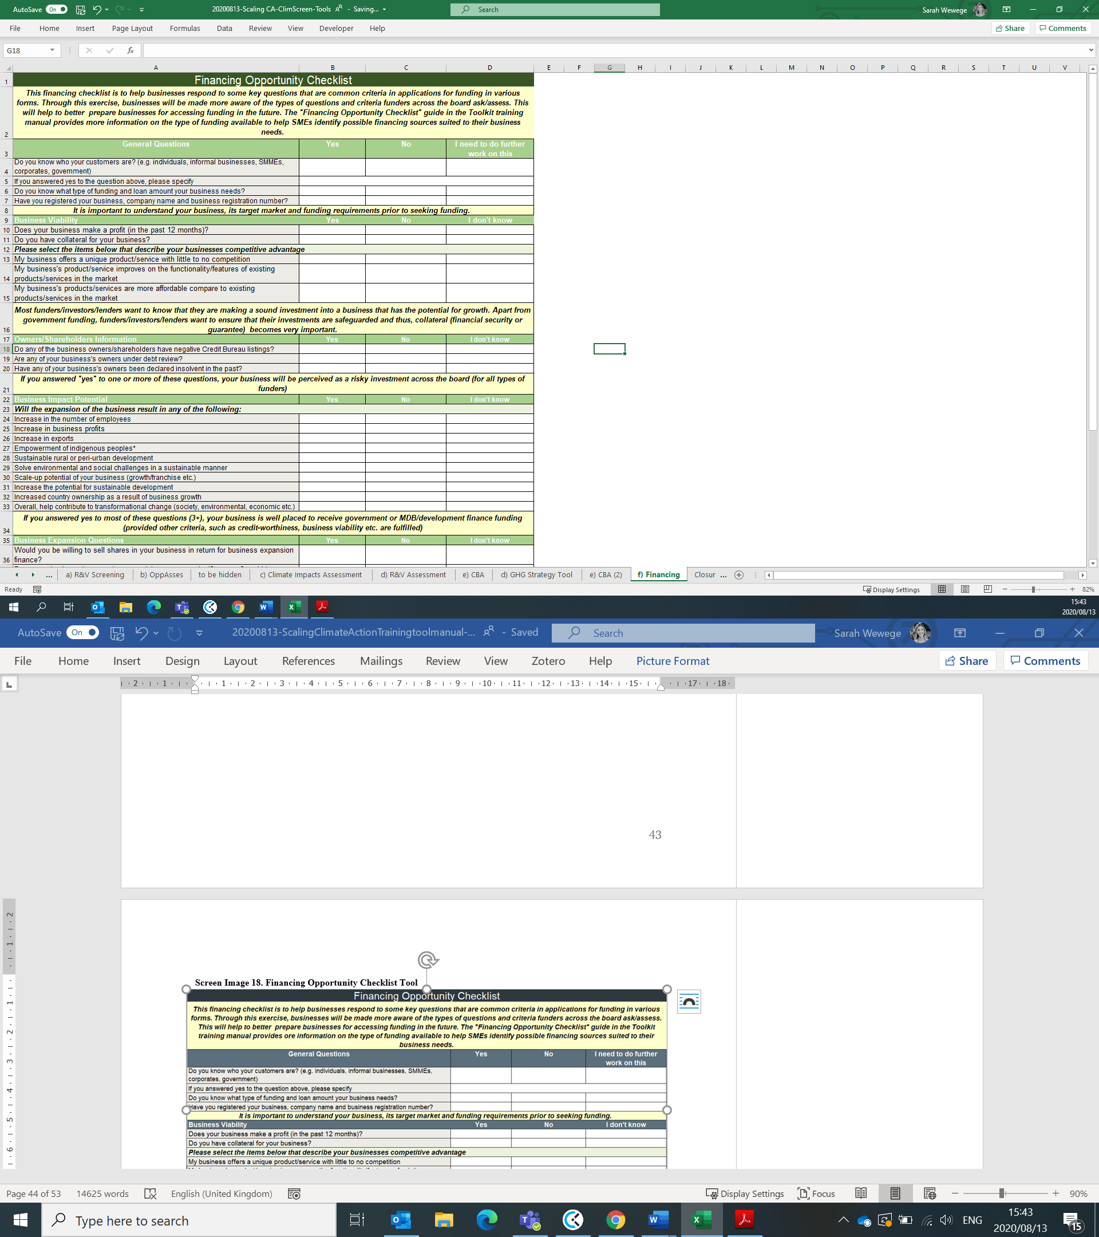
Screen Image 17. Financing Opportunity Checklist Tool
Once you have completed this step, you would have completed steps (a)-(g) of the Climate Risk Screening and Climate Opportunity Toolkit. Through this process, you should have a stronger understanding of the key climate financing crietria investors and funders require, as well as the potential climate risks to your business. Through this, you should have a good idea of what adaptation/mitigation actions your business should implement (and the opportunities available) based on the impacts of different climate risks to your business and their respective benefits or costs.

Toolkit 2: Business Carbon Footprint Toolkit

Purpose of this toolkit
The Business Carbon Footprint Toolkit will help guide SMEs to strengthen their emissions baseline assessment (as conducted in Part A), to increase the accuracy of their GHG emission reduction estimates and forecasts (calculate their carbon footprint), and to account for their actual emission reductions year on year, against the baseline and estimates (and hopefully reduce their carbon footprint over time).
Importance of GHG Accounting for Estimating your Carbon Footprint
Measuring and reporting on your business’s GHG emissions is important for a number of reasons:
- Cost-saving: GHG accounting helps your business identify what activities use a lot of energy, produce a lot of waste or use a lot of water and consequently, can help your business to reduce energy, waste or water use and therefore, save money.
- Attract new business: Cost-saving can help your business save money, allowing your business to focus resources where they are needed and increase your business’s competitiveness.
- Meet funders demands: Funders are increasingly requesting information on businesses GHG emissions. This is becoming an important aspect to securing financing.
Source: DEFRA, 2009

The objective of this toolkit is to ensure that SMEs can develop and present a business case for climate finance that supports GHG emission reduction strategies and, are able to report this information to potential climate funders in the future. This toolkit aims to estimate the business’s carbon footprint as a starting point and is a first step in the GHG Accounting process.
Specifically, the purpose of this toolkit is to:
- Help businesses to estimate their businesses carbon footprint
- Help business to reflect on ways to reduce decrease their carbon footprint, thus contributing to climate change objectives and helping to save costs for the business
- Measure and report on their GHG emission reductions annually
The tool will thus take the business through the following questions:
- What are the baseline emissions of the business activity (i.e. the business’s current carbon footprint)?
- What are the energy/fuel sources that contribute the most the carbon emissions?
- What are the energy/fuel sources that cost the business the most?
- What are the alternatives to decreasing these emissions and/or decreasing these costs?
It is important to note that this tool only asks businesses to consider scope 1 and scope 2 emissions- things that are within the organisational boundary (i.e. things that the business can control). Furthermore, this toolkit is not comprehensive but rather, focused on the energy/fuel type that the business uses and aims to calculate an estimated carbon footprint from these sources. At the end of this toolkit, the business should have a better handle on its energy/fuel expenditure and emissions and think through ways to reduce these.

Step a-b) GHG Accounting Tool
For businesses further along the business continuum, this tool will help to calculate the business’s GHG emissions baseline (carbon footprint) and report against this annually.

This toolkit builds on the outcomes of the GHG emissions reduction strategy tool in the Climate Change Risk and Opportunity Toolkit. The first part of the tool (Screen Image 18) requires that you collect the relevant activity data that will be needed to complete your business’s carbon footprint baseline. In this case, your baseline is the point against which you measure and compare any changes in emissions over time. In order to be able to report on emissions reductions, for example, it is critical that a baseline is established from which to measure.
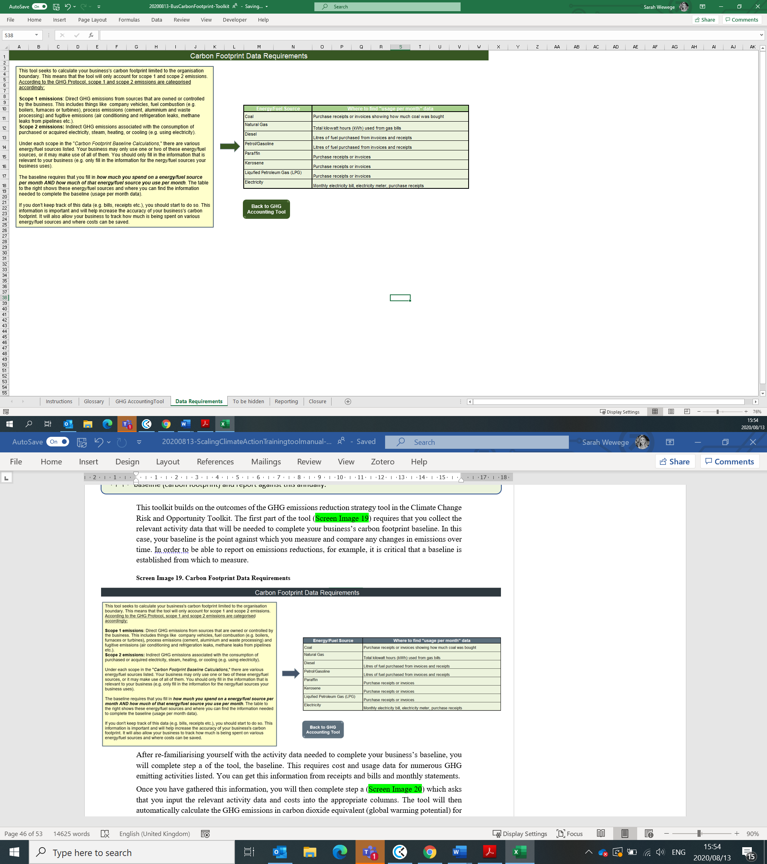
Screen Image 18. Carbon Footprint Data Requirements
After re-familiarising yourself with the activity data needed to complete your business’s baseline, you will complete step a of the tool, the baseline. This requires cost and usage data for numerous GHG emitting activities listed. You can get this information from receipts and bills and monthly statements.
Once you have gathered this information, you will then complete step a (Screen Image 19) which asks that you input the relevant activity data and costs into the appropriate columns. The tool will then automatically calculate the GHG emissions in carbon dioxide equivalent (global warming potential) for each energy/fuel source. These will then be automatically added up (both from scope 1 and scope 2) to give your business an idea of the total GHG emissions that your business produces in a month and year, and the corresponding costs.
The tool uses default emission factors to automatically calculate total GHG emissions from a fuel/energy source. However, if the business is able to find country-specific emission factors for this fuel/energy source, this information should be filled into the column title, “GHG emission factor.” This will then enable a more accurate GHG total to be calculated.
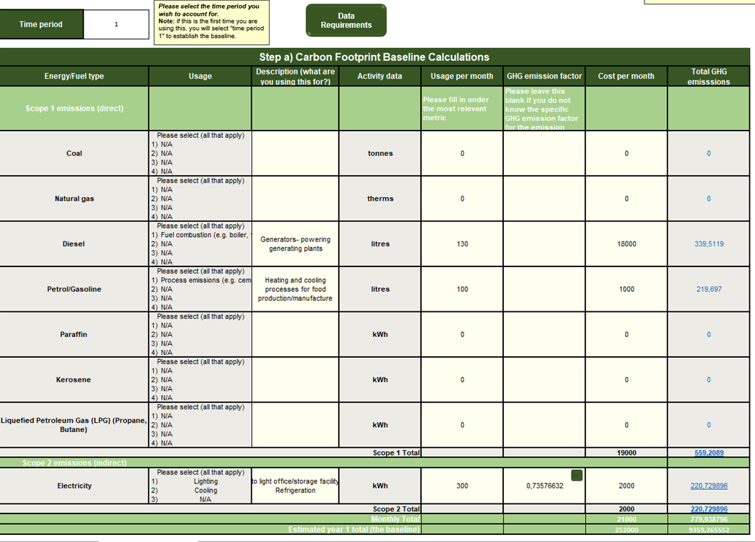
Screen Image 19. GHG baseline calculations

It is important to note that you will only fill in the “usage per month” and the “cost per month” for the applicable row. For example, while “tonnes”, “kWh” and “litres” are provided as options for “Diesel”- you will only fill in the relevant activity data for which you have information. If you know how many litres of diesel your company has consumed, then you will only fill in for the row that states “litres.” This applies for all of the various energy/fuel types.
Once step a has bene completed, you will use the values from “Total GHG emissions” as well as the total costs and input this data from the baseline into the table in step b (Screen Image 20).
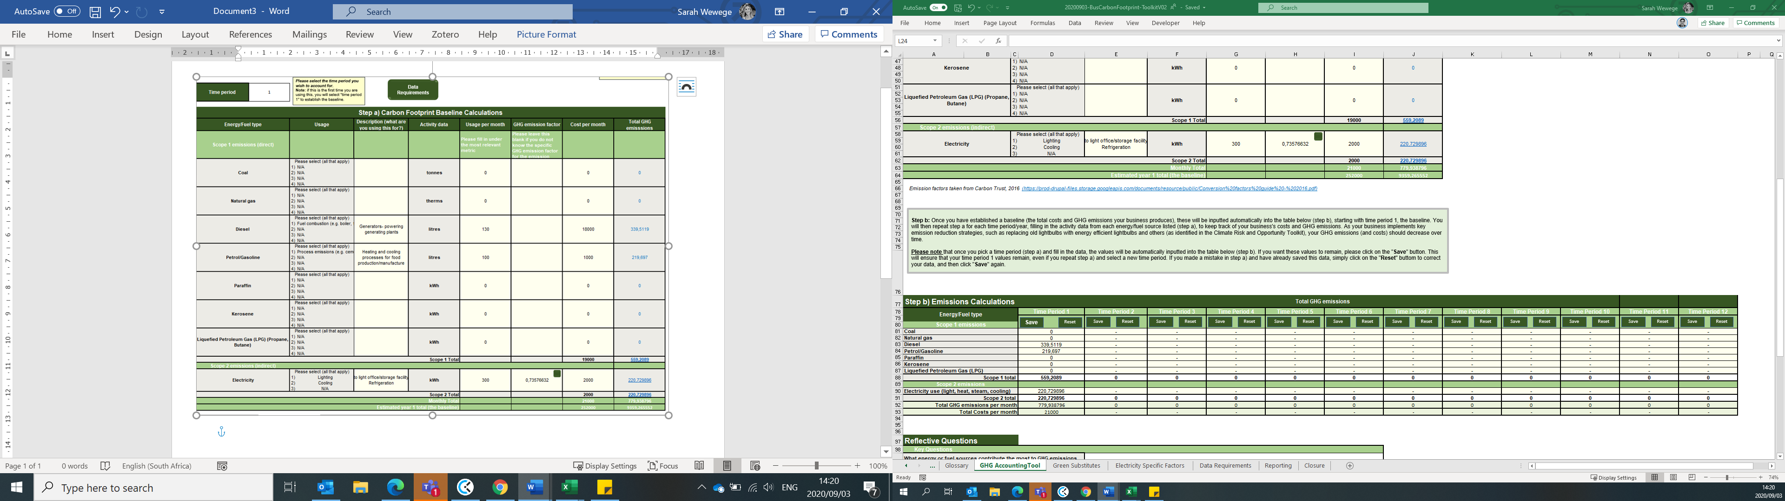
Screen Image 20. Emissions calculations over time
Step b provides a table that compares GHG emissions over a 12-year time period. You could use this to record your business’s progress as you implement your GHG emissions reduction strategies over time. Alternatively, you can change the years to months, measuring your progress over a shorter time period.
Please note that once you pick a time period (step a) and fill in the data, the values will be automatically inputted into the table below (step b). If you want these values to remain, please click on the "Save" button. This will ensure that your time period 1 values remain, even if you repeat step a) and select a new time period. If you made a mistake in step a) and have already saved this data, simply click on the "Reset" button to correct your data, and then click "Save" again.
The reflective questions (Screen Image 21) are there to help your business think through the main energy/fuel emitters and the associated costs. Through this exercise, your business may want to implement some of the GHG emissions reductions strategies identified in the Climate Change Risk and Opportunity Toolkit, such as replacing normal lightbulbs with energy efficient ones to help reduce emissions and save costs. Then, when you repeat this exercise the following month or year, you can see how this specific action has contributed to your business’s overall carbon footprint and total expenditure. The button titled “Explore Green Substitutes” will take you to another page where possible fuel/energy alternatives, which are more sustainable, are listed. This page (Screen Image 22), highlights not only possible alternatives to implement, but also provides an idea of the short-term and longer-term costs of this alternative. The purpose of this is to help your business to identify alternative energy/fuel sources that your business uses a lot of and that contributes significantly to business GHG emissions and costs, in order to save costs and reduce emissions.
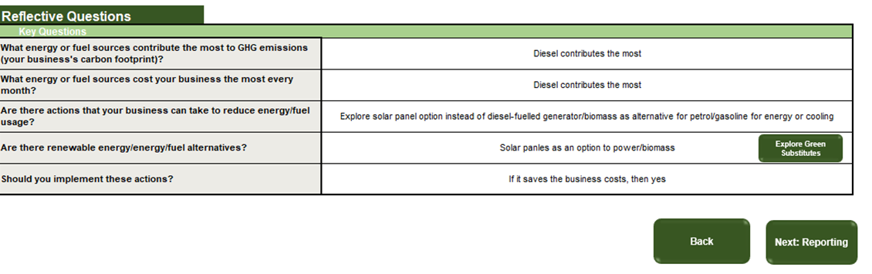
Screen Image 21. Reflective questions
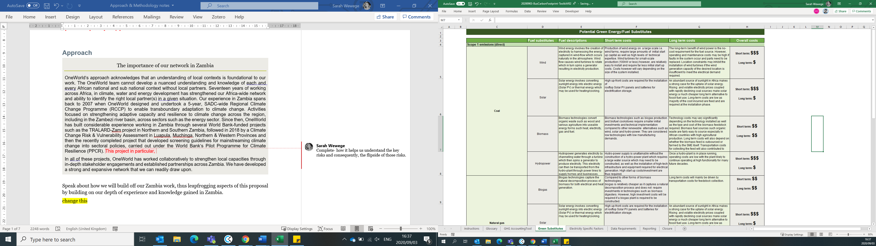
Screen Image 22. Green substitute
Once you have completed step a, b and answered the reflective questions, you will be directed to a GHG reporting Checklist, step c (Screen Image 23). This checklist will help make your business aware of the information required by potential investors. This includes your companies GHG emissions broken down according to scope as well as key company documentation and an understanding of why GHG emission changes have taken place. For example, if your overall GHG emissions decreased from year 1 to year 2 due to your business installing energy efficient lightbulbs, this must be clearly stated.
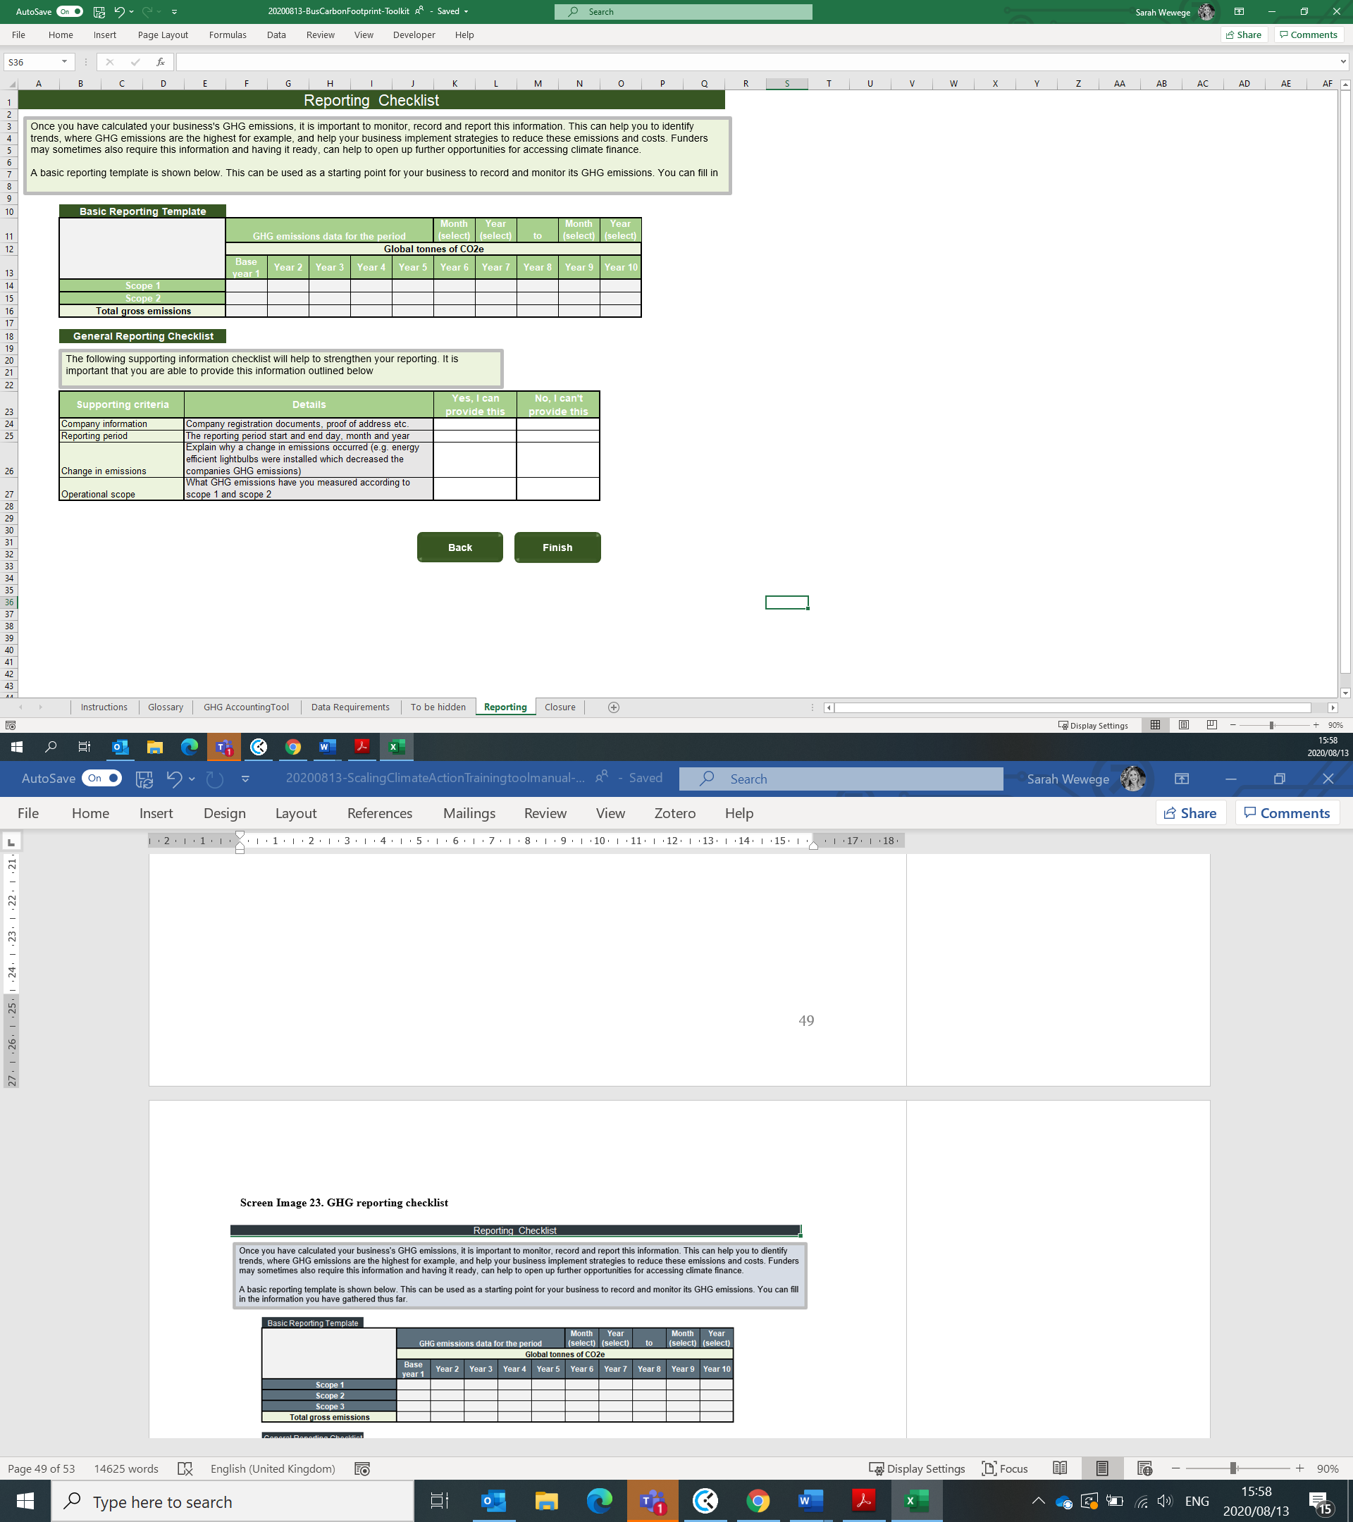
Screen Image 23. GHG reporting checklist

One you have completed the very general GHG reporting checklist, you would have come to the end of the toolkit. Ultimately, through this process of establishing your business’s carbon footprint, you should have a greater understanding of your business’s carbon emissions and costs. This knowledge can equip your business to identify opportunities for reducing carbon emissions, business risks and costs, as well as improving your business’s reputation.
While this toolkit provides a simple GHG Accounting approach through carbon footprinting, should your business wish to go into greater detail, there a number of sources available. A few of these are listed below:
- Carbon Trusts “Steps to energy saving: tools for SMES” available: https://www.carbontrust.com/resources/steps-to-energy-saving-tools-for-smes
- Guide on how to measure and report your greenhouse gas emission (https://bit.ly/2ZR3R7x)
- Greenhouse Gas Reporting for Small Businesses (https://bit.ly/3eb2963
- Greenhouse Gas Protocol: A Corporate Accounting and Reporting Standard (https://bit.ly/2DpuRDC

References
Bhatia, P. and Ranganathan, J. 2004. The Greenhouse Gas Protocol- A Corporate Accounting and Reporting Standard (Revised Edition). World Business Council for Sustainable Development (WBCSD). Available [Online]: https://ghgprotocol.org/sites/default/files/standards/ghg-protocol-revised.pdf
C2ES. 2019. Business Risks, Opportunities and Leadership. Climate Essentials. Available [Online]: https://www.c2es.org/site/assets/uploads/2019/04/business-risks-opportunities-and-leadership.pdf
Chamberlain, A. n.d. Greenhouse Gases Reporting: 5 Ways Transparency Helps Your Business. Environnemental Management Solutions (ERA). Available [Online]: https://www.era-environmental.com/blog/greenhouse-gases-reporting-business-transparency#:~:text=Complete%20and%20accurate%20GHG%20emissions,for%20businesses%20to%20be%20transparent.
CIF, 2018. Microfinance for Climate Adaptation: from Readiness to Resilience- Research brief. Climate Investment Funds. Available [Online]: https://oneworldgroup.co.za/wp-content/uploads/2019/04/CIF.Microfin.web_.rev4_.pdf
ClimaSouth E-Handbook N.8. Accessing climate finance: a step-by-step approach for practitioners. Prepared by Robert Tippmann, Ali Agoumi, Louis Perroy&ElskeVeenstra. ClimaSouth project, 2016
CONVERGENCES. 2019. Microfinance Barometer 2019. 10th Edition. Available [Online]: http://www.convergences.org/wp-content/uploads/2019/09/Microfinance-Barometer-2019_web-1.pdf
CPI, 2019. Global Landscape of Climate Finance 2019 [Barbara Buchner, Alex Clark, Angela Falconer, Rob Macquarie, Chavi Meattle, Rowena Tolentino, Cooper Wetherbee]. Climate Policy Initiative, London. Available at: https://climatepolicyinitiative.org/publication/ global-climate-finance-2019/
DEFRA. 2009. Guidance on how to measure and report your greenhouse gas emissions Department for Environment Food and Rural Affairs. Available [Online]: https://assets.publishing.service.gov.uk/government/uploads/system/uploads/attachment_data/file/69282/pb13309-ghg-guidance-0909011.pdf
Edie. 2019. SDGs becoming a ‘new compass’ for sustainable investing, survey finds. Edie newsroom. 10 April. Available [Online]: https://www.edie.net/news/7/SDGs-becoming-a--new-compass--for-sustainable-investing--survey-finds/
Electric, S. 2020. 6 Ways business can align with SDGs and make an impact. GRESB. 17 January. Available [Online]: https://gresb.com/6-ways-business-align-sdgs-make-impact/
Engel, H., Enkvist, P. and Henderson, K. 2015. How companies can adapt to climate change. McKinsey & Company. July 1. Available [Online]: https://www.mckinsey.com/business-functions/sustainability/our-insights/how-companies-can-adapt-to-climate-change
FAO. 2020. What is REDD+? Food and Agriculture Organization of the United Nations. Available [Online]: http://www.fao.org/redd/en/
IPCC, 2018. Global warming of 1.5°C. An IPCC Special Report on the impacts of global warming of 1.5°C above pre-industrial levels and related global greenhouse gas emission pathways, in the context of strengthening the global response to the threat of climate change, sustainable development, and efforts to eradicate poverty [V. Masson-Delmotte, P. Zhai, H. O. Pörtner, D. Roberts, J. Skea, P.R. Shukla, A. Pirani, W. Moufouma-Okia, C. Péan, R. Pidcock, S. Connors, J. B. R. Matthews, Y. Chen, X. Zhou, M. I. Gomis, E. Lonnoy, T. Maycock, M. Tignor, T. Waterfield (eds.)]. In Press
Kenton, W. 2020. Corporate Finance and Accounting. Investopedia. 27 April. Available [Online]: https://www.investopedia.com/terms/n/npv.asp
Mudombi, S. 2019. RoriMpete: Thinking outside the box – retrofitting water saving in conventional waterborne sanitation systems. CLIMATE CHANGE ADAPTION AND SMALL BUSINESS. TIPS, South Africa. Available [Online]: file:///C:/Users/Sarah/Downloads/TIPS_and_Flanders_Case_study_Loo_Afrique_March_2019.pdf
NASA. 2020. Overview: Weather, Global Warming and Climate Change. NASA Global Climate Change- Vital Signs of the Planet. Available [Online]: https://climate.nasa.gov/resources/global-warming-vs-climate-change/
Paul, A. 2019. FEATURE: Gender equity in climate finance- Why does it matter? Climate & Development Knowledge Network. 10 June. Available [Online]: https://cdkn.org/2019/06/feature-gender-equity-in-climate-finance-why-does-it-matter/?loclang=en_gb
Petrie, B., Martin, L., Petrik, L., Chapman, A. and Blignaut, J., 2016. "Strengthening Climate Resilience in the Kafue sub-Basin (SCRiKA) Project: Training Manual." Cape Town: OneWorld Sustainable Investments.
Petrie B, Midgley, S, Chapman, A, Hope, E. (2012). Thato ya Batho – Women Adapt to Climate Change. Written and produced for the Department of International Relations and Cooperation by OneWorld Sustainable Investments, Cape Town, South Africa.
Ranganathan, J., Corbier, L., Bhatia, P., Schmitz, S., Gage, P. and Oren, K., 2004. The greenhouse gas protocol: A corporate accounting and reporting standard (revised edition). Washington, DC: World Resources Institute and World Business Council for Sustainable Development.
TCR. 2019. Greenhouse Gas reporting for Small Businesses. The Climate Registry. Available [Online]: https://www.theclimateregistry.org/wp-content/uploads/2019/10/SBG_ES.pdf
TCR. 2015. Draft GHG Reporting Guidance for Small Businesses. The Climate Registry. Available [Online]: https://www.theclimateregistry.org/wp-content/uploads/2016/07/Final-Draft-Small-Business-Guidance.pdf
Thompson, K. 2018. What is a carbon footprint & why does it matter to my business? Ferguson. 8 February. Available [Online]: https://www.ferguson.com/content/trade-talk/business-tips/what-is-a-business-carbon-footprint-and-why-does-it-matter
Thompson, K. 2018. What is a carbon footprint & why does it matter to my business? Ferguson. 8 February. Available [Online]: https://www.ferguson.com/content/trade-talk/business-tips/what-is-a-business-carbon-footprint-and-why-does-it-matter
Timperley, J. 2018. Interactive: How climate finance ‘flows’ around the world. CarbonBrief. 6 December. Available [Online]: https://www.carbonbrief.org/interactive-how-climate-finance-flows-around-the-world
Tonmoy, F and Rissik, D. 2019. Climate Change Risk Management Tool for Small Businesses in Queensland: Part 1- Information booklet. Queensland Government. Available [Online]: https://www.nccarf.edu.au/sites/default/files/attached_files/Small%20Business%20Tool_DRAFT.pdf
UKICP. 2020. Adaptation Case Studies. UK Climate Impacts Programme. Available [Online]: https://www.ukcip.org.uk/case-studies/
United Nations Climate Change. 2020. Nationally Determined Contributions (NDCs). Available [Online]: https://unfccc.int/nationally-determined-contributions-ndcs#eq-5
United Nations. n.d. Sustainable Development Goals. Sustainable Development Goals Knowledge Platform. Available [Online]: https://sustainabledevelopment.un.org/sdgs
UNFCCC. 2020. The Paris Agreement. United Nations Climate Change. Available [Online]: https://unfccc.int/process-and-meetings/the-paris-agreement/the-paris-agreement
Wyns, A. 2018. It’s all about the Money: Climate Finance explained in 9 Questions. ClimateTracker. 8 June. Available [Online]: http://climatetracker.org/money-climate-finance-explained-8-questions/
Zokaei, K. 2013. Environmentally friendly business is profitable business. The Guardian. 14 October. Available [Online]: https://www.theguardian.com/sustainable-business/environmentally-friendly-sustainable-business-profitable

